

UMAYMAH SIGBATHULLA

*Freelance Architect*

*Designer and Content Writer*

MASTER PLANNING ARCHITECTURE & URBAN DESIGN

Website, Online Presence & Social Media Platforms

# DIFFERENT SOCIAL MEDIA PLATFORMS

1. Website – Generates a single all-information site
2. App for Website
3. WhatsApp/ Telegram – Business communication
4. LinkedIn – To promote the projects and work ethic at Mofa
5. Instagram – To generate a go-to page for younger architects and new clients
6. Facebook – Generating a bigger audience
7. Twitter – Attracting a bigger audience

# MARKETING STRATEGIES (Source: www.digitallibertyindia.com)

Different types of marketing bring in different results:

* **Content marketing** – To generate relationships through trust, which in turn brings revenue.
* **Inbound marketing** – Making your company accessible to people who need your services.
* **Social media marketing** – Consistent and relevant content to build a community that networks.
* **Search engine marketing**
* **Search engine optimization (Preferred)** – Utilizing modern web based technologies that help in reaching targeted audience by using key words.
* **Pay-per-click –** Search advertising to create an impression.
* **Account-based marketing (ABM) and retargeting** –ABM content impacts what your customer is doing by initiating change and establishing an emotional connection.
* **Earned media and PR** – Reputation building.
* **Referral programs** – Recommendations from reliable/ trusted sources go a long way.
* **Industry events**- Teamwork and collaboration can result in industry specific events that garner attention from bigger clients and candidates.
* **Website & graphic design services** – Always look to floor your audiences with smart graphics.

# WEBSITE PRECURSORS

**Things to Focus On:**

* Target audience
* Marketing message
* Purpose of the website
* The site as an economic opportunity
* Brand identity

**Requirements for Quick Pick Up in The Market:**

* Traction
* Branding strategy
* Marketing plan
* Platforms to post on
* Consistent posts (for a year at least)

**Parameters:**

* Analytics
* Bounce Rate
* Landing Page
* Content
* Site Traffic
* A/B Testing
* Eye Tracking
* Site Speed

**Important Features:**

* Security
* Navigation
* Appearance
* Mobile Friendly

# COLOUR PALETTE

**Choices:**

* All black and white



* Monochrome with single bright color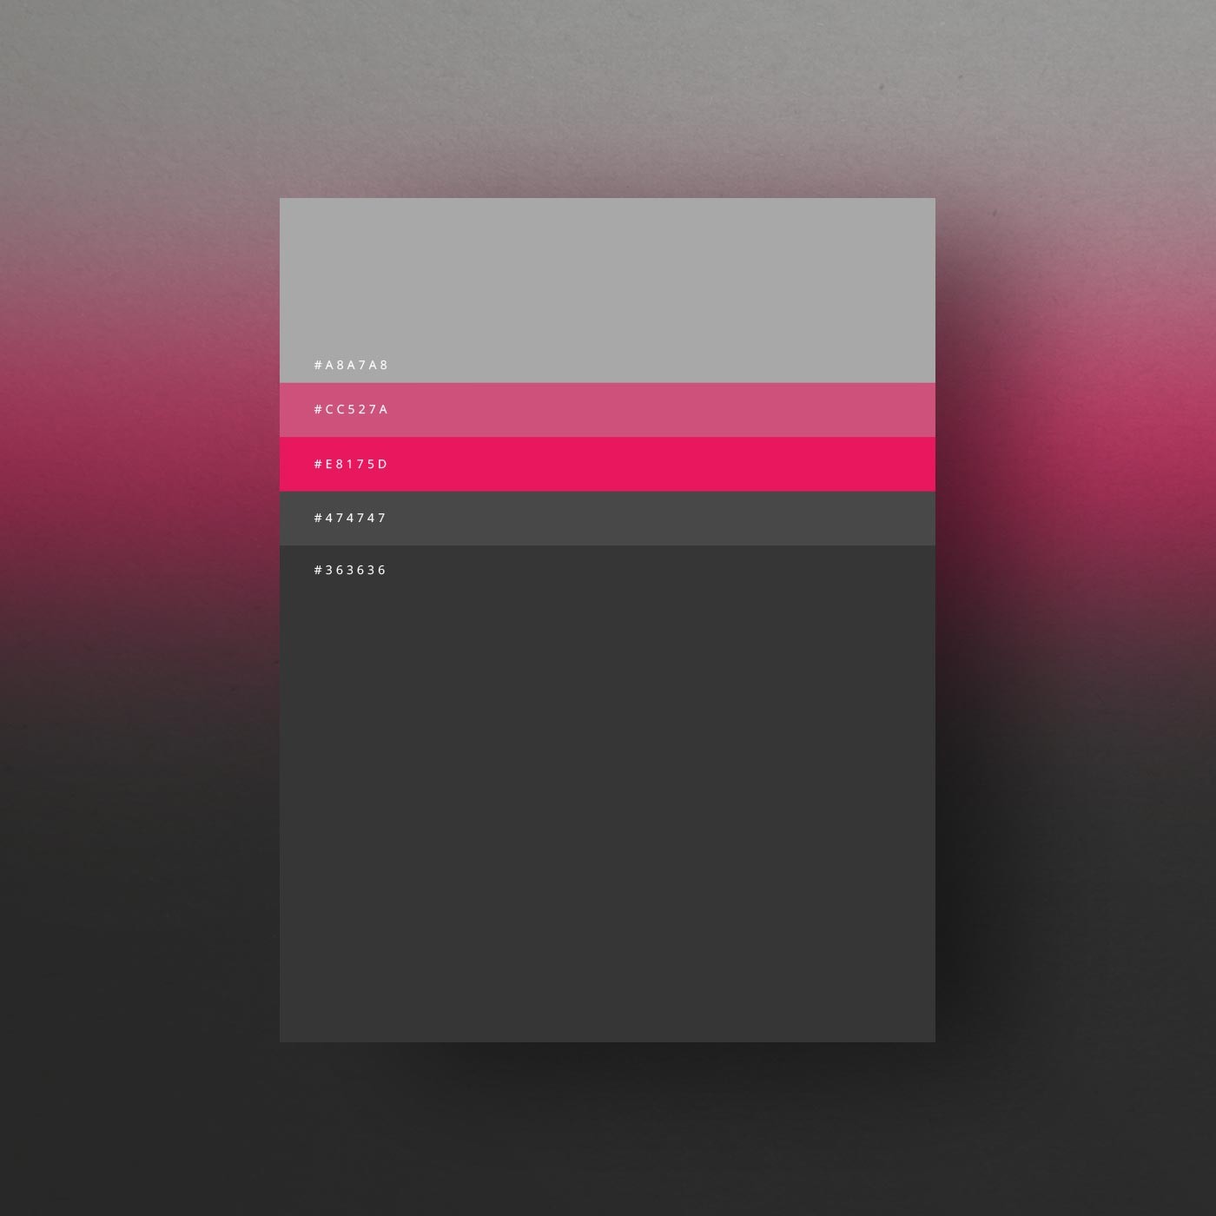

# WEBSITE CONTENTS

## PAGE 1: HOME PAGE

* Overview and Employment Relationship:

MOFA Architects is an architectural firm intent on being a great place to work for Architects and other professionals who are driven by excellence and a great work ethic. *(Source: MOFA Handbook)*

* Vision, Mission and Values:

At MOFA Architects we believe in delivering innovation and inspiring and sustainable designs with on-time delivery, for our clients. *(Source: MOFA Handbook)*

* Company Overall Goals:

Our goal is to be an interdisciplinary local firm with global standards to design smarter and sustainable solutions. *(Source: MOFA Handbook)*

* About the firm:

Established almost half a decade ago, Mofa Architects is a boutique firm in Hyderabad specializing in master planning besides urban design, and architecture. The firm caters to a broad clientele, both local and international, to deliver dynamic, efficient and sustainable design solutions. With an upcoming wing dedicated solely to landscape design, we at Mofa seek to build projects that align with our client's goals and objectives.

Our portfolio comprises holistic and long-lasting designs from small scale and detail-oriented residences, to large scale well connected gated communities. Experienced planners, skilled architects, creative interior designers, innovators, consultants and strategists constitute the team at Mofa. Proponents of a diligent and focused work ethic, at Mofa, each member values your time and strives to deliver nothing short of the best.

At the time of its inception, the team comprised of five architects led by Ar. Mohammed Faisal. Now the strength has grown to over 25 employees. Multi-faceted and engaged in improving construction, design and research standards, at Mofa, we nurture projects right from the beginning to the end with utmost attention and commitment.

The Mofa fraternity, united by our purpose, is ready to bring your dreams to reality. We are ready, are you? *(Source: Self Write-up)*

* Design Philosophy:

Mofa aims to design and build pragmatic and responsible architecture. The practice carries out applied research and investigates present and future trends that impact design. The study on global changes in demographics has enabled MOFA to evolve a new typology in social housing. We also extensively studied the thinking patterns of Millennials. This analysis became the premise for a semantic shift in the design of workspaces for a large multi-national client. Services provided:

Master Planning, Architecture, Urban Design, Landscape Design, Interior design

* Office-Pet Friendly
* 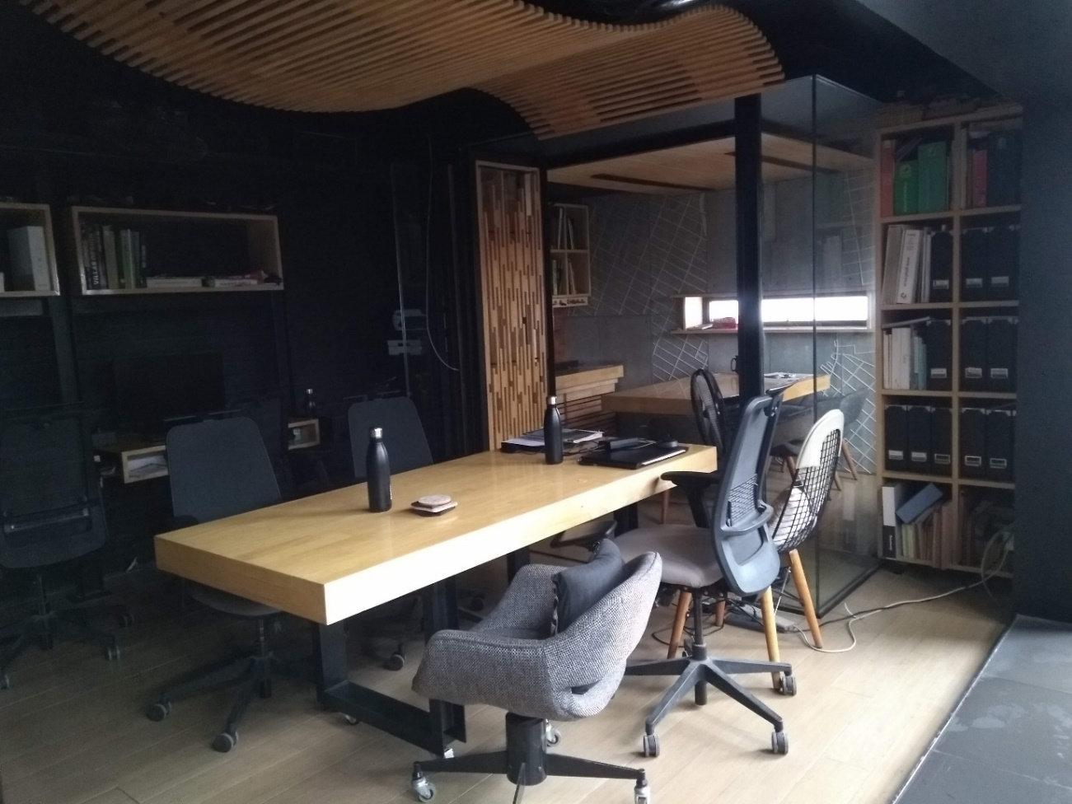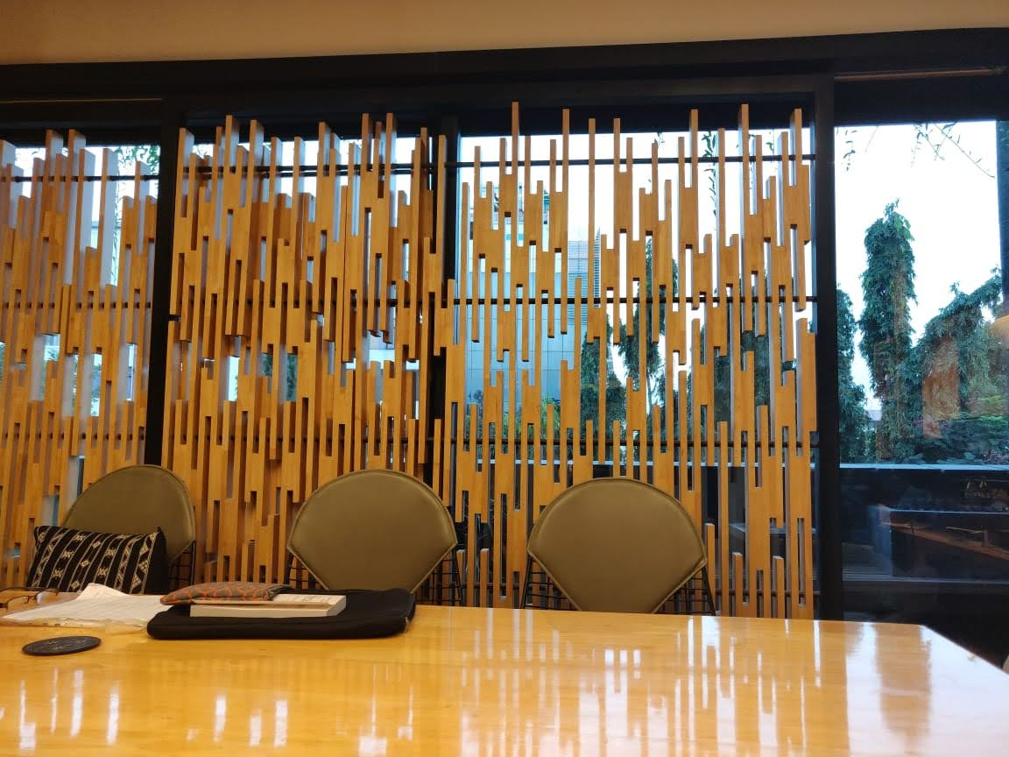Image

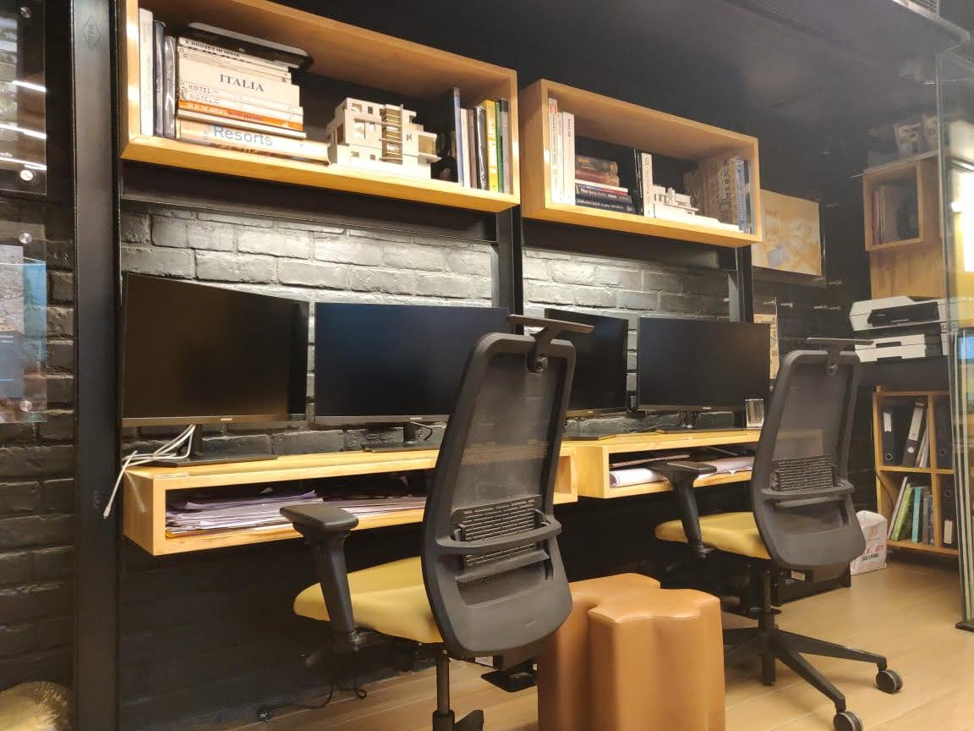

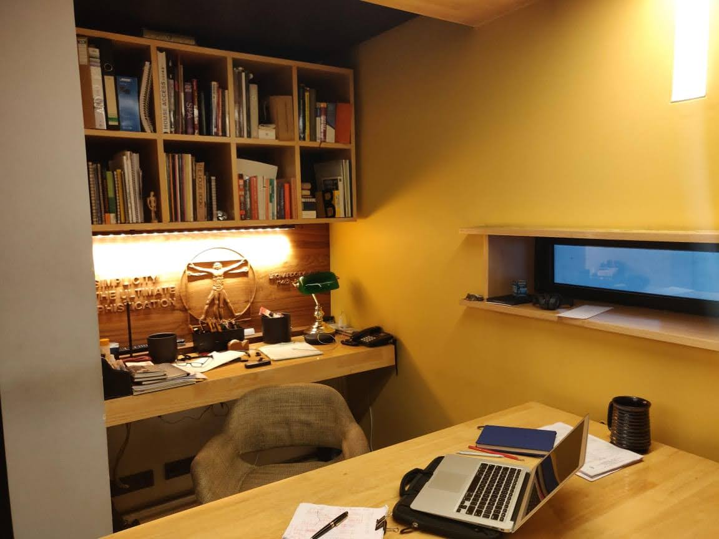

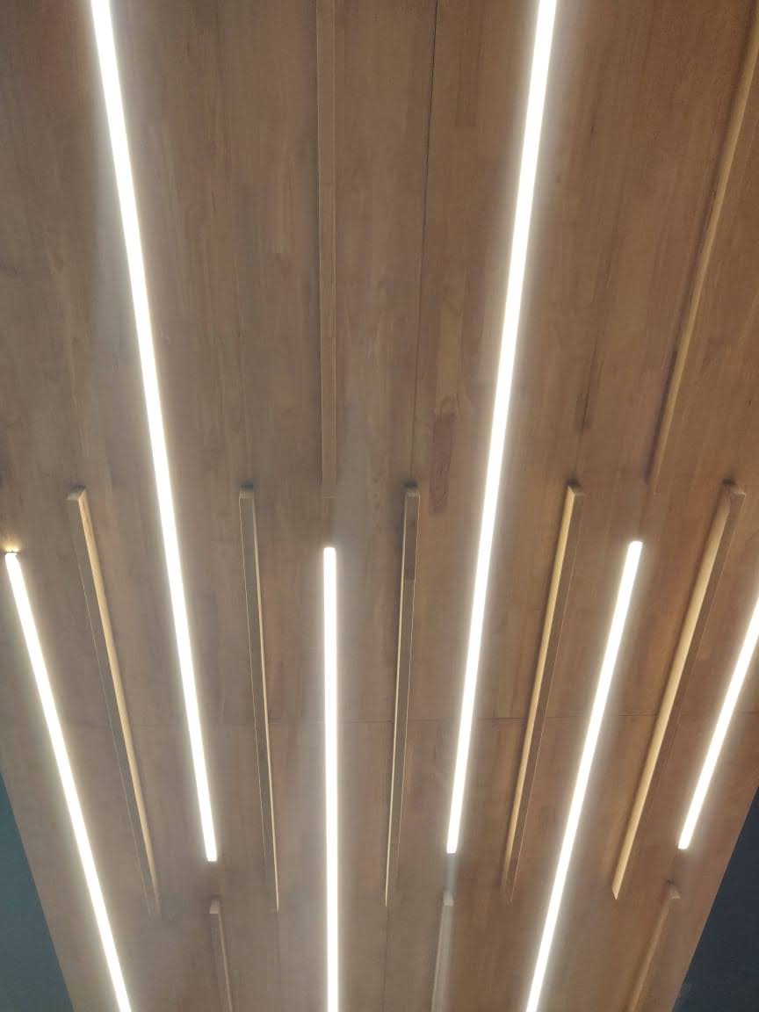

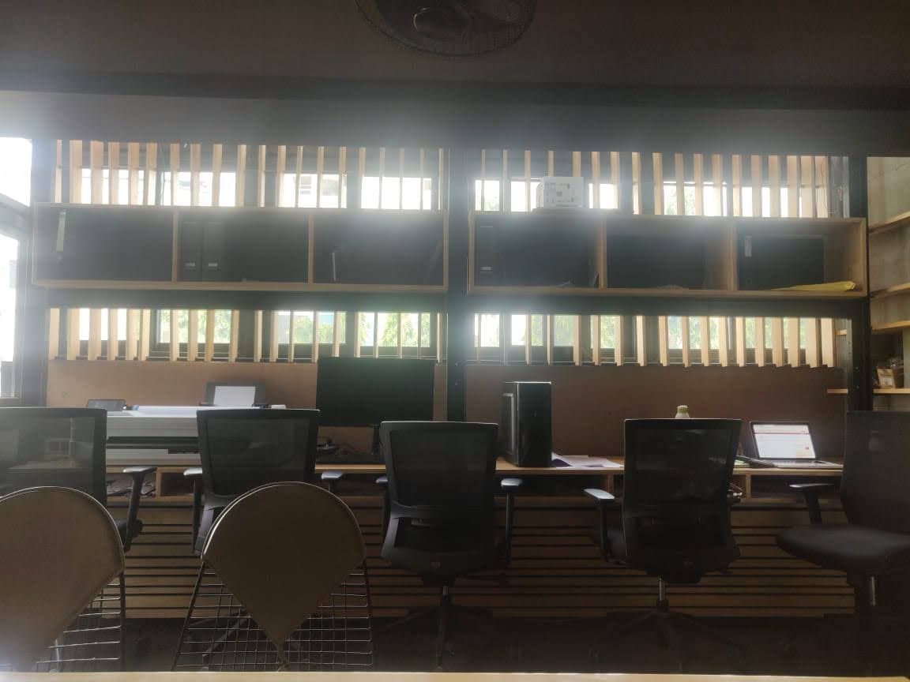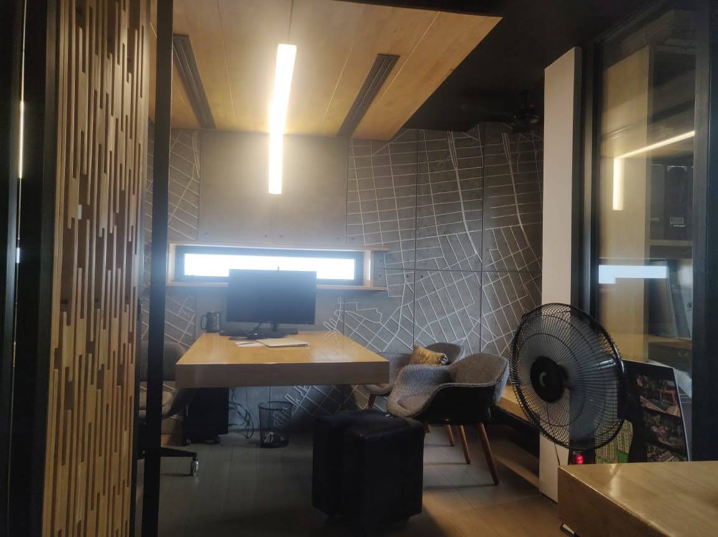

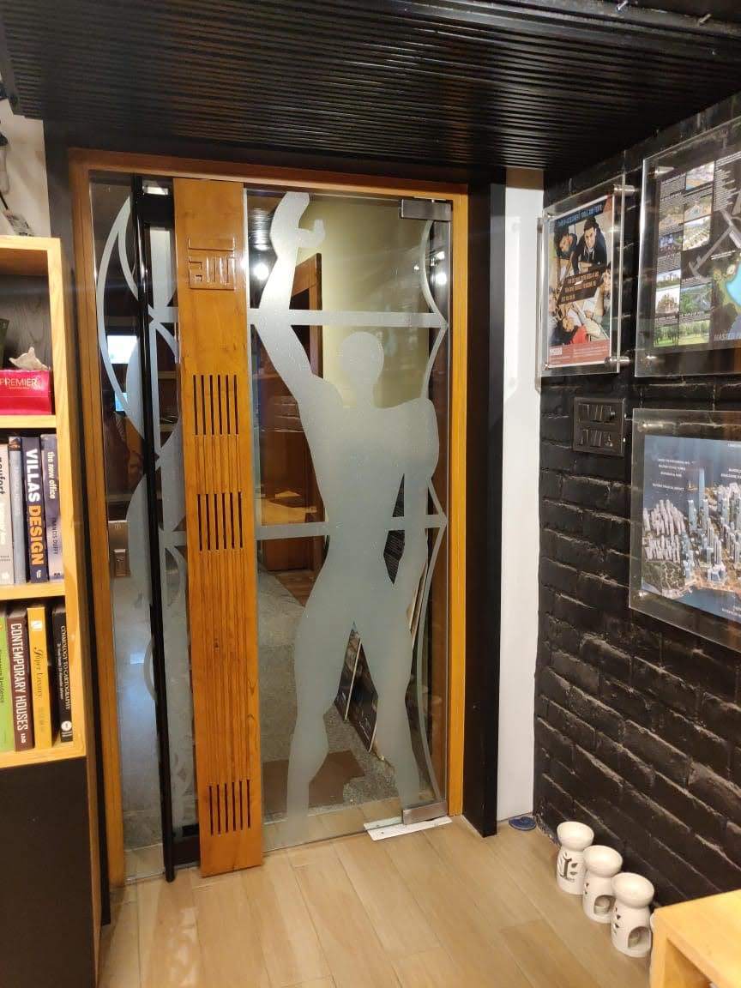

PAGE 2: TEAM

* **Principal architect- Ar. Mohammed Faisal**

Mohammed Faisal is a Chartered Architect and Urban Designer, having over 22 years of experience in multi-disciplinary consultancies in Asia & the Middle East. Faisal established his boutique architectural practice – MOFA in 2016. It is a professionally focused consultancy interested in creating efficient architecture. Faisal is a founding partner of SCDCorp, a virtual design firm offering BIM services globally. *(Source: Edited from LinkedIn)*

* Specialties: Master planning, Residential development, Urban design, Architecture
* **Senior architect- Ar. Bhanu Prakash Chary**

With 12 years of experience in architectural design and managing projects at various stages, Bhanu Prakash Chary has worked on diverse assignments. He gained vast knowledge while working with reputed and renowned architectural firms. A portfolio comprising of leading international & local clients from different parts of India, Bhanu's professionalism is unmatched. He is an expert in client interaction, space planning, construction drawings, contractor interaction, material selection and team management.

* Specialties: Master planning, Hi-rise Residential development
* Software proficiency: AutoCAD, Revit, Structural, Sketch-up *(Source: Edited from LinkedIn)*
* **Senior architect- Ar. Tirumala Naren**
* **Senior architect- Ar. Srujana**
* **Junior architect- Ar. Neekitha Hatvalne**
* **Junior architect- Ar. Kenneth Jangala**
* **Junior architect- Ar. Davera Praful**
* **Junior architect- Ar. Ameen Siddiqui**
* **Junior architect- Ar. Bindhya Varma**
* **Junior architect- Ar. Saniya Tahreem**
* **Intern- Mariam Sumayyah**
* **Intern- Ajay**
* **Intern- Santha Sreekari**
* **Intern- Rabaab Fatima**
* **Intern- Pragnya Thakur**
* **Intern- Zahra**
* **Design team /Studio+ Images +Videos (15s)**
* **Stories/ Feedback**
* Keerthana Lakkapragada: Working with Mofa was a wonderful experience. The knowledge I gained, concerning sensitivity in each project, helped me grow both, professionally and personally. I haven't come across another firm which works on small details with so much enthusiasm in my entire career.

## PAGE 3: PROJECTS

* **Residential-** Multi-residential
* **Retail**
* **Master Planning**
* **Urban Design**
* **Retro-fit**
* **Landscape design**

## PAGE 4: CLIENTS

* **Info and company**
* Ashoka Developers & Builders Ltd.
* Praneeth Group
* DA Developers
* Fidesto Projects Pvt. Ltd.
* Indis
* Eugen Laboratories Pvt. Ltd.
* KRC Raheja
* **Testaments**

## PAGE 5: NEWS

* **Competitions**
* **Updates**

## PAGE 5: JOIN

* **Events and news**
* **Awards**
* **Research & Learning**
* **Available Openings**
* **Application Details**

## CONTACT INFORMATION

* **Twitter Link**
* **LinkedIn Link**
* **Instagram Link**
* **Address:** *#14, Level-3, Road no.10, Banjara Hills, Hyderabad, India- 500034*
* **Phone No.:** *+91 9949116218*
* **Email:** [faisal@mofa.co.in](mailto:faisal@mofa.co.in) ; [info@mofa.co.in](mailto:info@mofa.co.in)
* **Map**

# FORMAT FOR EACH PROJECT TILE

TITLE

1. Tagline
2. Picture
3. Area
4. Scope of services
5. Status
6. Location
7. Concept
8. Description (200-250 words)

Note: Each tile can lead to a Blog post/ detailed description of the project.

# MASTER PLANNING PROJECTS

## PROJECT 1: Raigarh Masterplan

1. Tagline: Pursuit of Nature/ Inherently Natural/ Inherently Organic
2. 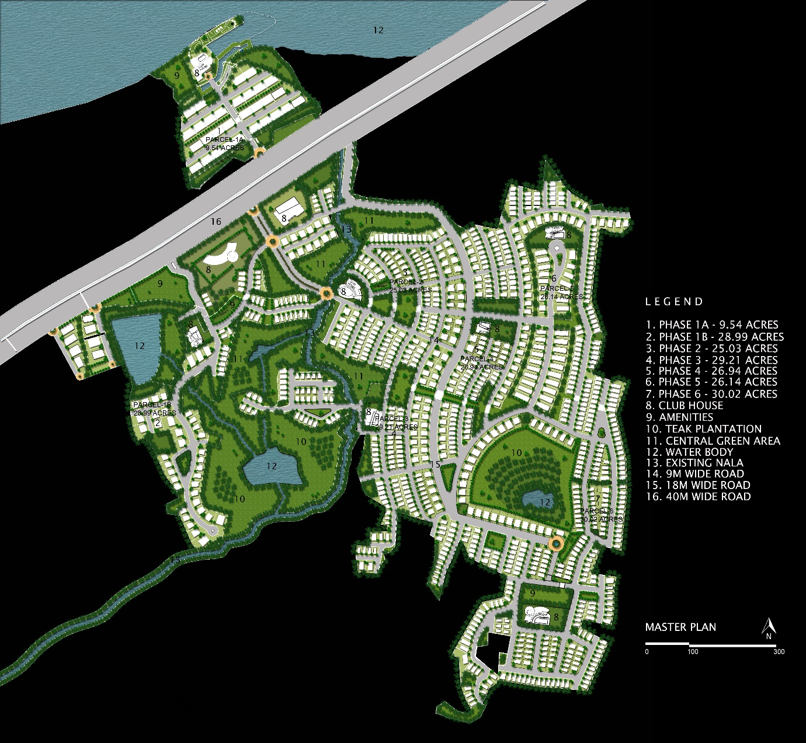Picture:
3. Area: approx. 250 Acres
4. Scope of services: Concept Master Planning
5. Status: Design Ideation Complete
6. Location: Raigarh, Mumbai-Poona Highway
7. Concept
8. Description: The project canvas for the Raigarh gated living is an unmatched blend of serenity and dynamism that encourages diversity and inclusion. It comprises an untainted site with the picturesque Western Ghats framing the background. Ponds, streams and teak plantations ascertain the design constraints of the project empowering progress through integrated solutions.

An accretive approach to master planning, the proposal entails six phases of expansion. The design elements adhere to the natural topography of the site. Despite this, the entire development is walkable and, the green corridors connect the various urban spaces through shaded paths and driveways. The 18m wide driveways organically join the arterial road to the web of 9m wide roads that connect to all corners of the development.

The concentration of the built forms is on the northern and eastern side of the site plan. In compliance with local bye-laws, the project boasts of lush naturescapes with living quarters and public amenities. These spaces, streams and green spaces invite and compel the residents to explore the delightful environment.

The plots vary from 350 to 800 sq. yards and host either, Chateaus of 5000 sq. ft., Villas of 3000 sq. ft. or Dwellings of 2000 sq. ft. These residences can serve as second homes or weekend getaway homes for the buyers, who primarily live in the metropolitan Mumbai and Pune.

## PROJECT 2: Pre-Clinical Research Organization

1. Tagline: Where Science meets Architecture/ Designing Science/ Nurturing Science
2. 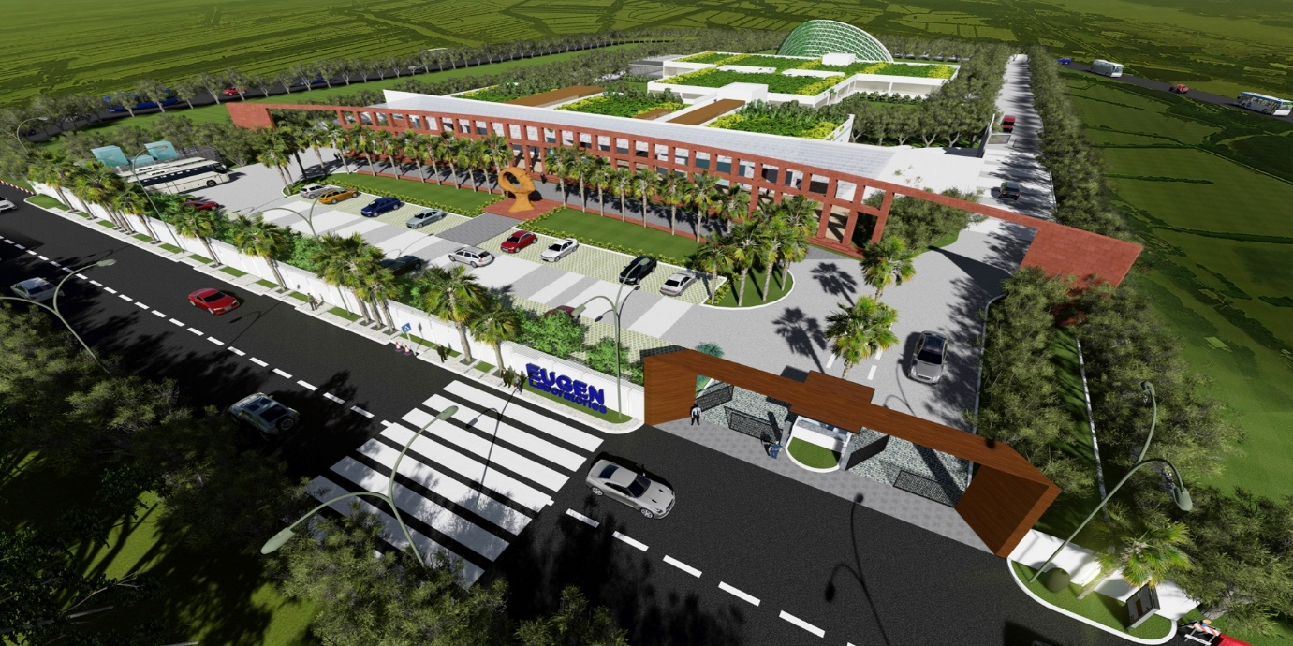Picture:

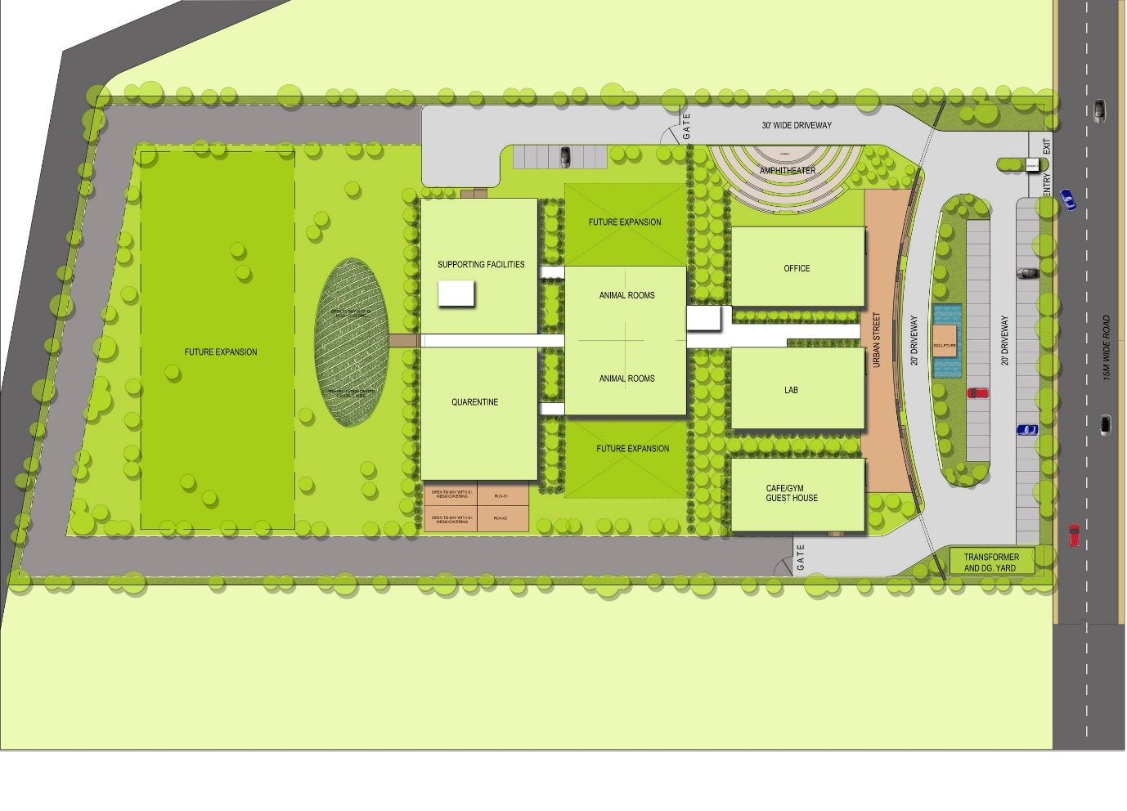

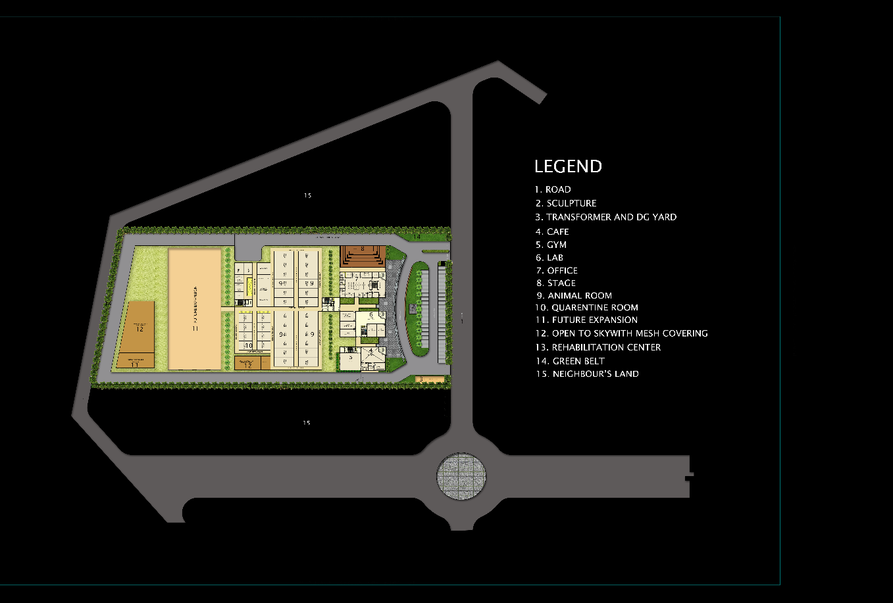

1. Area: 6.64 Acres
2. Scope of services: Concept Master Planning
3. Status: Design Ideation Complete
4. Location: Vizag
5. Concept
6. Description: Located on the outskirts, the Eugen Laboratories Pvt. Ltd. is a pre-clinical research centre developed with precision and care. The plan explores the potential of science and seeks to aid the trials from a spatial perspective. The 'Form Follows Function' approach adopted in the masterplan gives the project a minimal and modern appearance. Despite its modest appearance, the pre-clinical lab will possess futuristic technology that meets safety standards.

The site is situated such that it is bounded on north and south by neighbouring plots. However, it connects to a primary road in the east and a collector road in the west. This orientation enables future expansion on-site without putting pressure on the prime access points. The plan meticulously incorporates qualitative design parameters like daylight, artificial lighting, energy efficiency, acoustics, thermal comfort and ease of circulation quantitatively. Additionally, the MEP and HVAC services required for the efficient performance of the lab received specialised care.

The project features two categories of spaces, living quarters and research and development zones. A gym and a cafe complement staff accommodation. The other side of the plan houses clinical trial rooms, an R&D department, waste management rooms, a rehabilitation centre, a corporate office and a primates support area. Clean and dirty corridors with separate accesses from each clinical room connect various R&D chambers in the floor plan. Arrangement of the rooms encourages ease of accessibility and increases the functional output of the structure.

## PROJECT 3: Madhurawada Rushikoda Masterplan

1. Tagline: Shaping Discovery/ The Joy of Creativity/ Exploring the Unexplored
2. 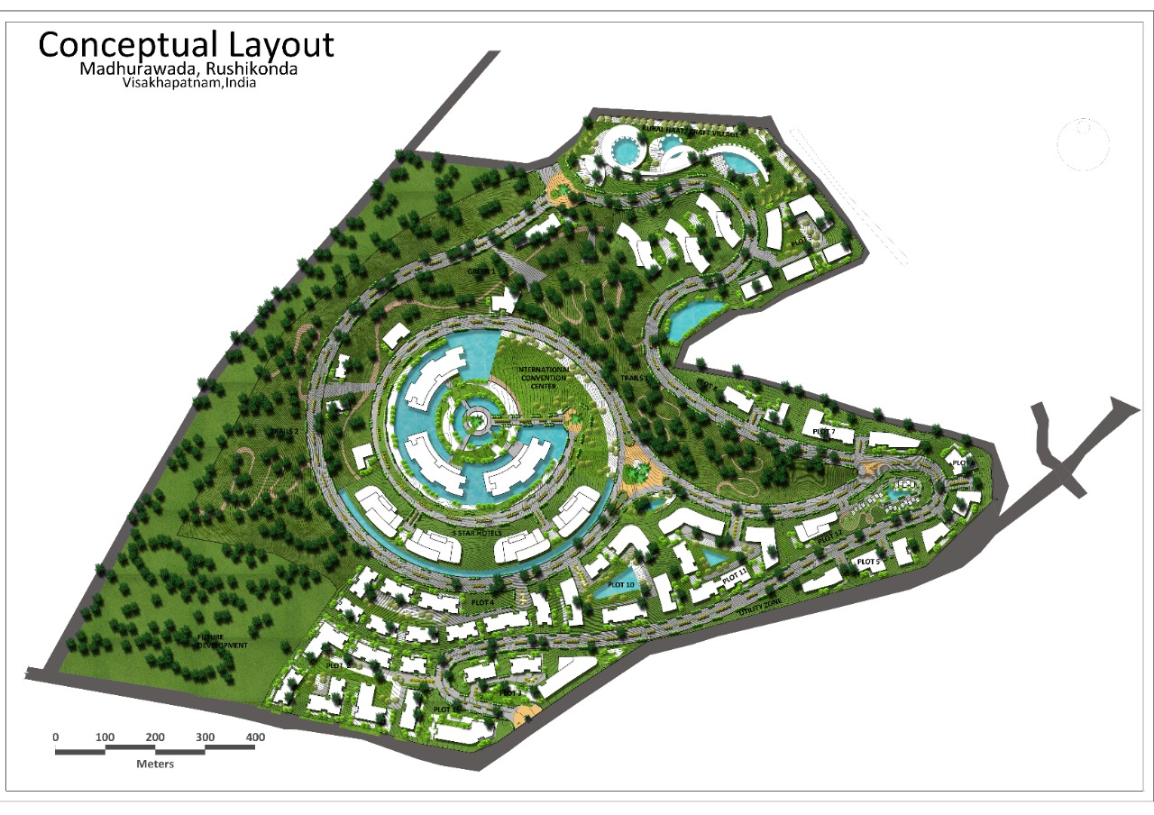Picture:
3. Area: approx. 250 Acres
4. Scope of services: Concept Master Planning
5. Status: Design Ideation Complete
6. Location: Raigarh, Mumbai Poona High Way
7. Concept
8. Description: The sprawling masterplan showcases a unique balance between natural and built entities. The organically evolved design interweaves nature trails and water bodies with buildings.

At the heart of the site, the International Convention Centre is the origin of the design. The three blocks are surrounded by moats and anchored to the central circle through three individual roads that join each block radially inwards. The central ring spirals out as a road and connects the five-star hotels and individual plots with the mini forest and the craft village. Impeccably designed for better accessibility and efficient connectivity, the driveways gradually become more organic as they reach the periphery. Numerous small water bodies tucked between the blocks elevate the texture of the master plan.

The highlight of the masterplan is the Rural Haat on the north-eastern side of the site. It boasts of a plethora of activities relating to the local craftsman. The craft village is beneficial to the artisans as it gives them the opportunity of generating revenue and promoting dying art forms. Mindful of its importance, this part of the development is inviting and rejuvenating. Engaging elements like ponds, nature trails, sculptures and semicircular buildings provides the charm that attracts tourists. The individual units allow visitors to interact and engage with the craft community at close quarters and learn about the native and traditional art forms.

## PROJECT 4: Bhumiraj- Navi Mumbai- Masterplan

1. Tagline: Transit Oriented Development/ Luxury in the Lap of Nature

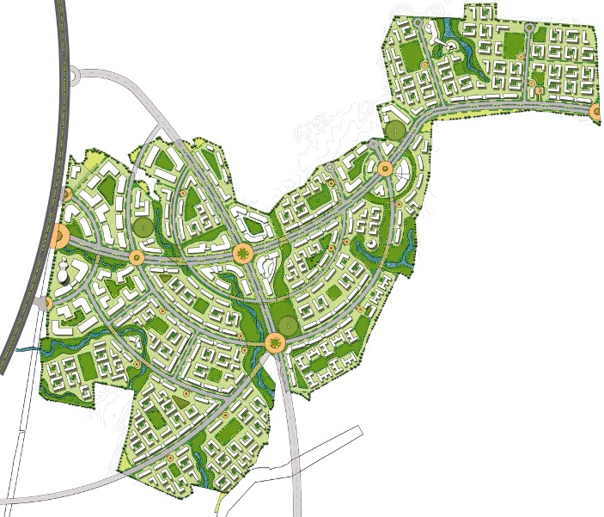

1. Picture:
2. Area
3. Scope of services: Concept Master Planning
4. Status: Design Ideation Complete
5. Location: Navi Mumbai
6. Concept
7. Description: A piece of intelligent and artistic planning, the Bhumiraj Masterplan is set along the Navi Mumbai-Pune Corridor. A holistic approach to design overcame the challenge the unconventionally shaped site posed. The site has a focal big semi-regular shape that extends into the north-east.

The principal access to the site is from the highway. Here, three semi-circular junctions’ welcome visitors into the campus. Adaptable and spacious, the layout of the built environment has numerous access points to the site. A multitude of buildings, varying in both form and function, are systematically distributed across the region.

Three arterial roads running in curves intercept the topography throughout the campus. The junctions where these roads intersect, equipped with traffic round-a-bouts, assist unhindered vehicular flow. Radiating from one such intersection is a set of arc-shaped connector roads that produce radial and angular parcels. The parcels of land, interwoven with lush plantations, adjoins several built structures. These structures follow either an organic plan or a rectangular plan for the building typology.

A web of greenery and bio-swales stretches across each of these parcels unifying, the entire plan. These natural forms create a pattern that binds all the entities together. The project is a perfect example of a union between nature and urban planning.

## PROJECT 5: DA Developers Forest Walk

1. Tagline: Encompassed by Nature/ Thriving in the Wilderness
2. 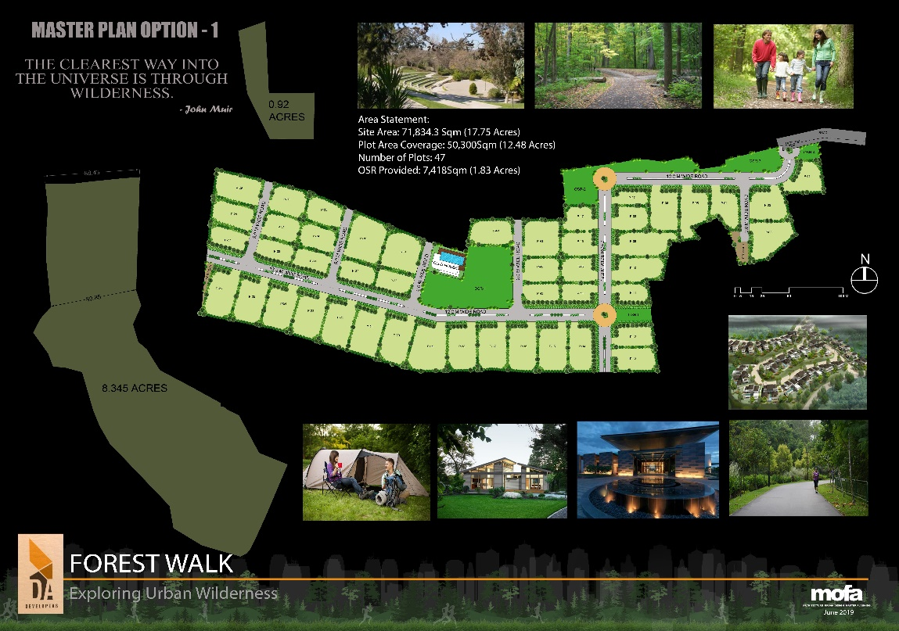Picture:
3. Area: 17.75 Acres
4. Scope of services: Concept Master Planning
5. Status: Design Ideation Complete
6. Location: Moinabad
7. Concept: Exploring Urban Wilderness
8. Description: A collaboration to create healthy and sustainable living spaces for people to live, work and heal, Forest Walk comprises 47 plots for developing private homes. It aims at exploring urban wilderness through integrated living. Located on the outskirts of Hyderabad, the project is in Moinabad, a plotted residential development with generous sections of land and excellent educational institutions.

Sporting impeccable natural surroundings, the masterplan sought to optimize the functional usability of the site. The site is accessible through 12m wide primary roads that narrow to 9m wide carriageways. Two service plots located on either end cater to the needs of the residents. A clubhouse and an open field are located centrally for easier accessibility. Amenities that promote health and wellbeing like a gym, swimming pool, play spaces, and walking tracks supplement it.

The individual plots vary in shape and size. Despite this, each parcel of land is separated from its neighbouring lots by a row of trees. Small shrubs line the perimeter of each plot, promoting greenery. The plants, shrubs and trees planted throughout the site are both ecologically sensitive and environmentally conscious. The project fosters the spirit of living and growth in nature within the urban landscape of the city.

## PROJECT 6: Fidesto Dhayari Master Plan

1. Tagline: A Climate of Change/ Sculpting Climate Sensitive Design
2. Picture: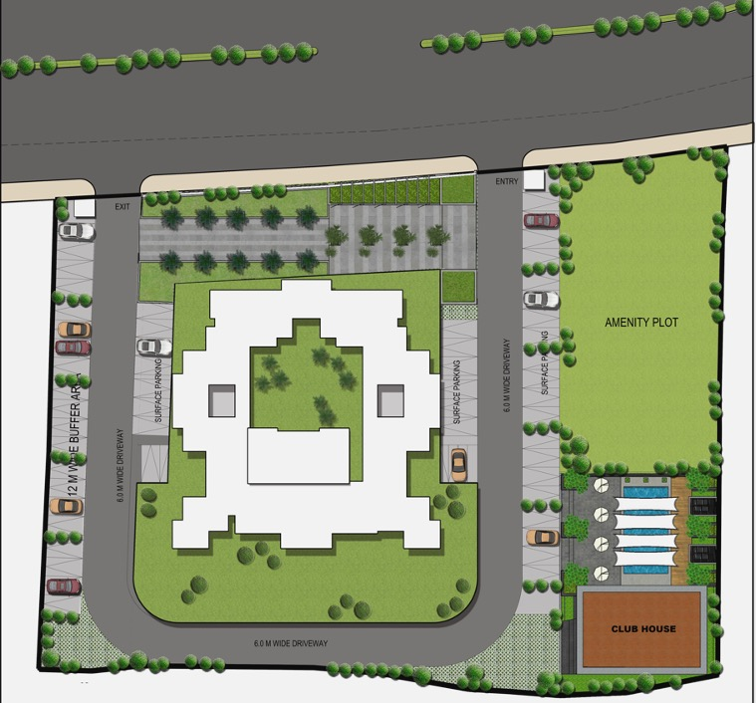
3. Area
4. Scope of services: Concept Master Planning
5. Status: Design Ideation Complete
6. Location: Dhayari, Pune
7. Concept:
8. Description: Surrounded by scenic hills and greenscapes, Dhayari is an upcoming neighbourhood of Pune. This suburb is at the junction of Sinhagad Road and NH4 and exhibits excellent transport links. Like many others, the Fidesto project is in this hub of residential architecture.

One enters the plot through a unidirectional 6m wide driveway that bends around the block and terminates on the road of its origin. On the eastern side, surface parking followed by an amenity plot flank the entryway. To the west, the verdant patio gives way to the building. This patio extends from the entry to the exit-way, providing all-round connectivity.

The recessed facades of the block are both aesthetic and protective. These recesses shield the interiors from harsh daylight and subsequent weathering. The building orientation is such that it creates a play of light and shadow over all surfaces, thereby reducing internal temperatures. The central cutout, designed to serve as the courtyard of the residential unit, sports social interaction. It is also the lung space of the beautifully sculpted masterplan that pours in ample amounts of light.

The amenity plot to the east is an open ground where one can play games like cricket, football and badminton. It connects to the clubhouse via a deck that encircles an aquamarine swimming pool. By doing so, the plan generates distinct areas for living and leisure. This arrangement breaks the monotony of the site and provides good approachability from all sides.

## PROJECT 7: Ashoka Forest Walk

1. Tagline: Symphony of Spaces/ A New Way of Living
2. 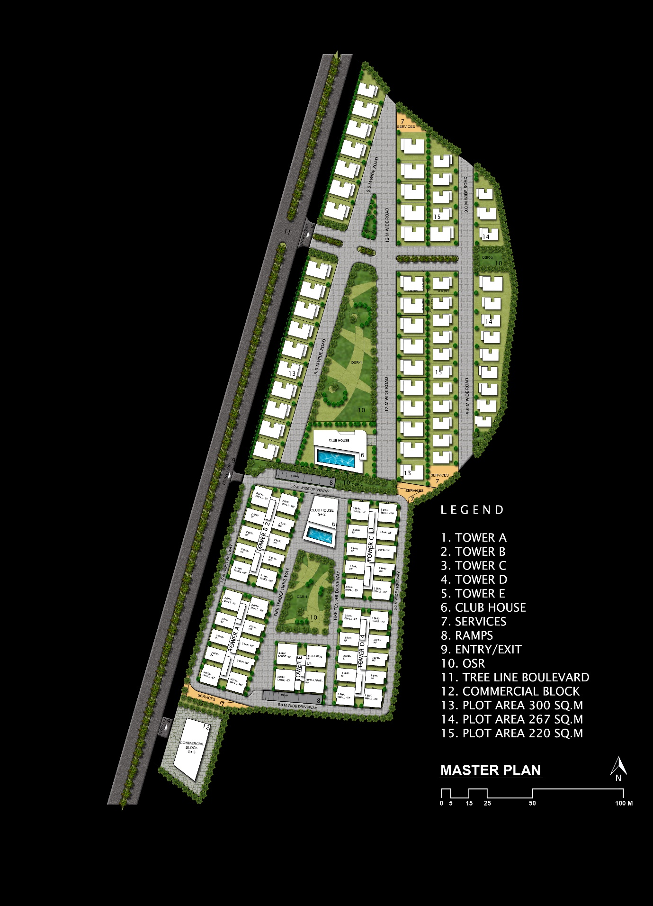Picture:
3. Area: 10 Acres
4. Scope of services: Concept Master Planning
5. Status: Design Ideation Complete
6. Location: Doolapally
7. Concept
8. Description: The Ashoka Forest Walk aims to create optimally utilized land parcels for affordable housing. An exploration of the principles of master planning, different housing typologies were sampled to generate multiple options for the masterplan. The final design proposal is a combination of villas and condos classified into two sectors. The northern quarter comprises low-density individual residential plots and, the southern quarter incorporates high-density apartments.

Accessible through two entryways, the development adjoins a tree-lined boulevard. Two 9m and one 12m wide lanes dissect the plotted layout such that the distribution of roads ensures maximum accessibility to each plot. The streets focus on interweaving the landscape with the built environment. The edge of the site abutting the boulevard has land parcels of 267 sq. yds. The area of other land parcels varies from 220 sq. yds. to 300 sq. yds.

In the southern sector, a 5m wide fire tender driveway runs around the periphery. This quarter comprises five towers of high-rise and mid-rise apartments with a clubhouse and a central playing area. A commercial block, with its separate access, is located in the southernmost corner of the site. The masterplan for the project is brimming with amenities while providing maximum housing within the city folk's budget.

## PROJECT 8: Ashoka Green Planet

1. Tagline: Celebrating Connectivity/ Communi-city
2. 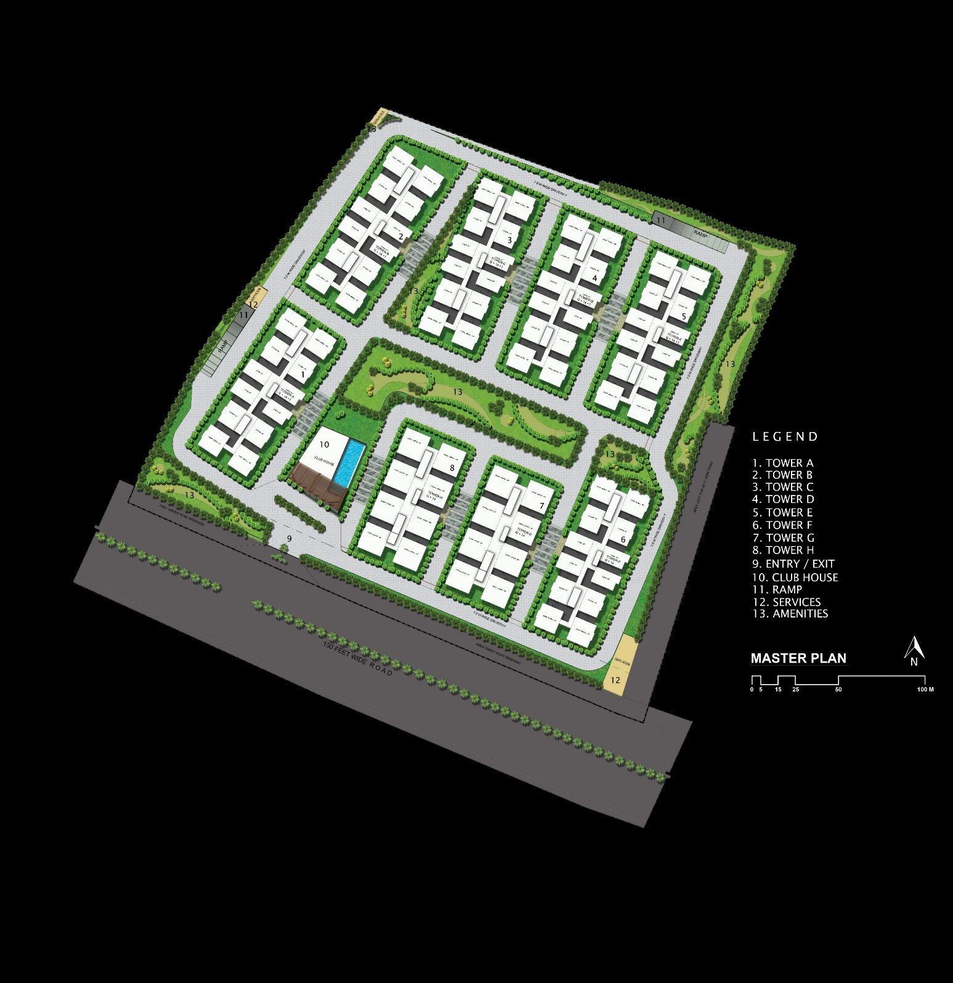Picture:
3. Area: 11.22 Acres
4. Scope of services: Concept Master Planning
5. Status: Design Ideation Complete
6. Location: Mokila, Hyderabad
7. Concept
8. Description: Set in the upcoming and sought after residential locality of Mokila, 40kms north of Hyderabad, Ashoka Green Planet boasts of lush green foliage and well-planned connectivity. The project focuses on nurturing the spirit and wellbeing of the people of tomorrow, our children. The design premise seeks to establish a safe interface between the towers and their surroundings for a child-centric masterplan.

Several child-related studies in the Research & Development field, carried out before planning, led to careful design decision-making. Underground parking was opted for over surface parking to reduce vehicular circulation that hinders the safety of children. Two ramps along the periphery, one in the north-east and one in the north, mitigate vehicular movement between the towers.

Eight towers were designed with recesses to integrate open areas with individual units. The arrangement of the blocks is such that each building overlooks an amenity. Six towers comprise twelve units on each floor, while two towers comprise eight apartments on each floor. The difference in the number of apartments in the buildings allows for flexible layouts and multiple condominium typologies.

An endeavour in integrated sustainability, the midrise apartment complexes of eight units blend seamlessly into its neighbourhood. The project is bye-laws pliant and, the design complies with specifications for services.

## PROJECT 9: Ashoka Urbania

1. Tagline: The World at Your Doorstep/ Amenities Meet Tranquility/ At the Heart of Everything
2. 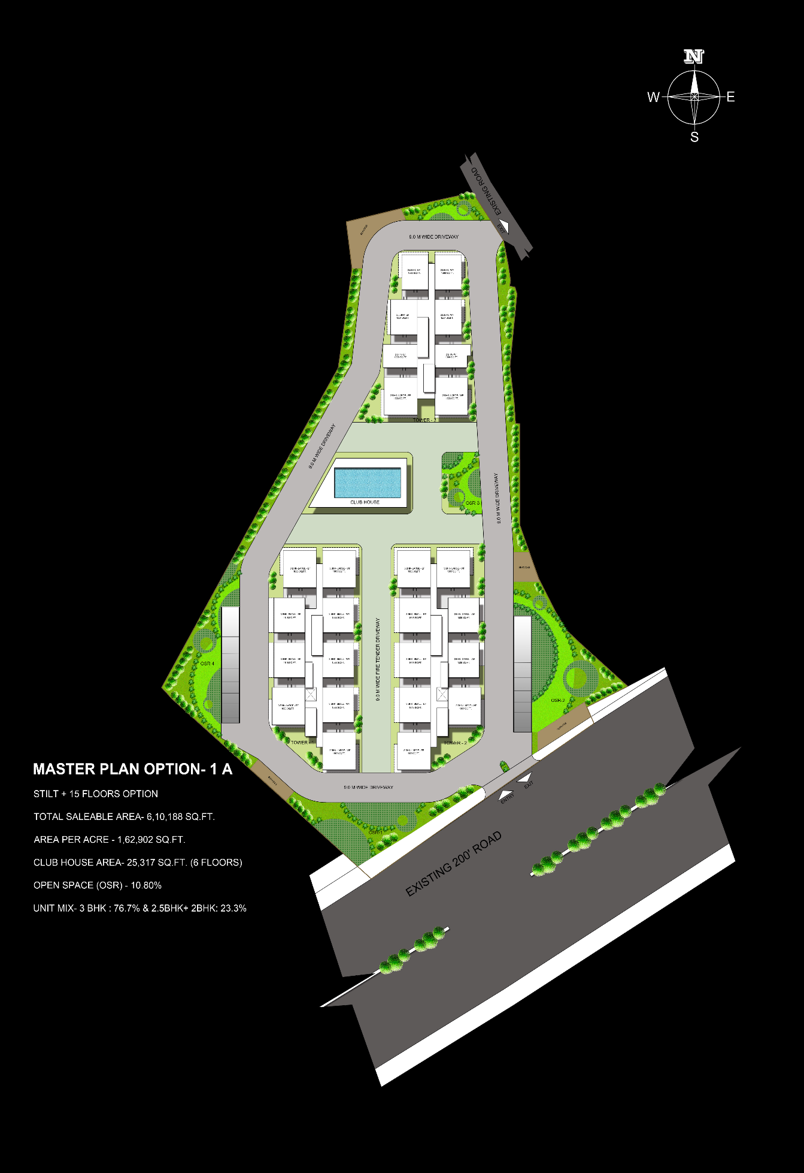Picture:
3. Area: ~14Acres
4. Scope of services: Concept Master Planning
5. Status: Design Ideation Complete
6. Location: Shamshabad
7. Concept
8. Description: Shamshabad is a growing suburban and commercial locality of Hyderabad in close affinity to other upcoming environs. In the heart of this district lies the Ashoka Urbania master plan which, is simple yet efficient.

Entered and exited via two access points, the triangular plot provided an unusual opportunity to engage with space-making and climatology. A 9m wide driveway winds its way around the three towers. It acts as both the fire tender driveway and the primary route of vehicular movement to the ramps. Stilt parking provided more open space on the site and allowed spacious layouts for tower orientation.

The layout caters to convenient access to the numerous amenities. Of these, a centrally situated clubhouse with a surplus of indoor activities and a rooftop swimming pool is the highlight. The three blocks enveloping it are high-rise developments, comprising 15 floors each. The orientation of the units is to achieve optimal privacy, vivid daylighting and breathtaking views.

The proposal enlists two different tower typologies. In the north, a single tower sports 2BHK units of area 1008 sq. ft., 2.5BHK units of 1284 sq. ft. and 1334 sq. ft. and 3BHK units of the size 1803 sq. ft. Two towers in the south comprise 3BHK units in three sizes, small, medium and large. These units are of varying sizes 1538 sq. ft., 1615 sq. ft. and 1803 sq. ft. The variety of spaces supports a diverse community in the prospective region.

## PROJECT 10: Kalakriti Artqbe

1. Tagline: Celebrating Creativity/ Gallery of Joy/ Reflecting artistic sensibility
2. 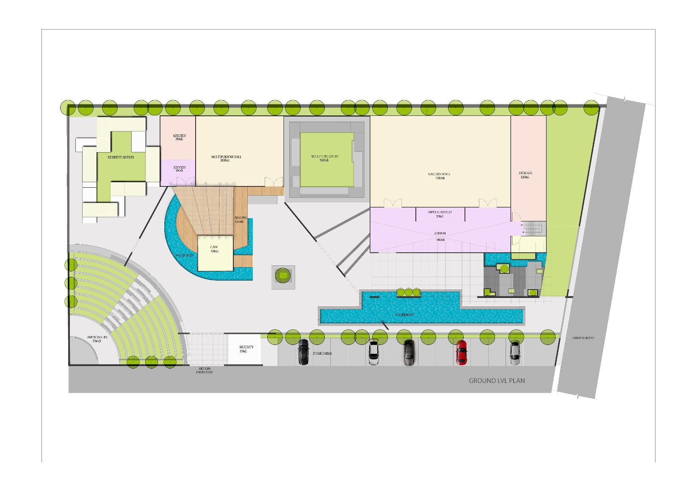Picture:
3. Area:
4. Scope of services: Design Ideation, Planning and Interior Design
5. Status:
6. Location: Hyderabad
7. Concept:
8. Description: The expression of creativity is called art. Architecture, in its myriad forms, is the articulation of this creativity. The masterplan for Kalakriti Artqbe evolved in line with this ideology. It is an art gallery that seeks to uplift and provide a platform for budding artists, artisans and admirers.

The masterplan caters to the aspirations of both the visitors and the artists. As one enters the campus through the southern access, they cross the 3760 sq. ft. open-air theatre. Enchanting people through open mic nights and bringing plays to life, the amphitheatre can seat over 200 viewers. When moving east, two water bodies on either side of the doorways welcome visitors into the gallery and the sculpture court. A 1400 sq. ft. atrium with an impulse display precedes the 43oo sq. ft. gallery. The atrium gives access to the 1200 sq. ft. storage space, the restrooms and the staircase.

Akin to adaptive spaces, the multipurpose hall can hold classes, group sessions and much more. Responsive to the needs of the artist community, the design incorporates residences for on-site artists. It allows artists and artisans to create, interact and showcase their talent on the same campus. Outdoor public spaces like the café were placed in between the residences and the gallery to invite spectators to experience the best of both worlds of an artist’s life.

## PROJECT 11: Indis Viva City Masterplan

1. Tagline: Panorama of life/ Creating Soulful Spaces/ Imbibing a Utilitarian Lifestyle
2. Picture:

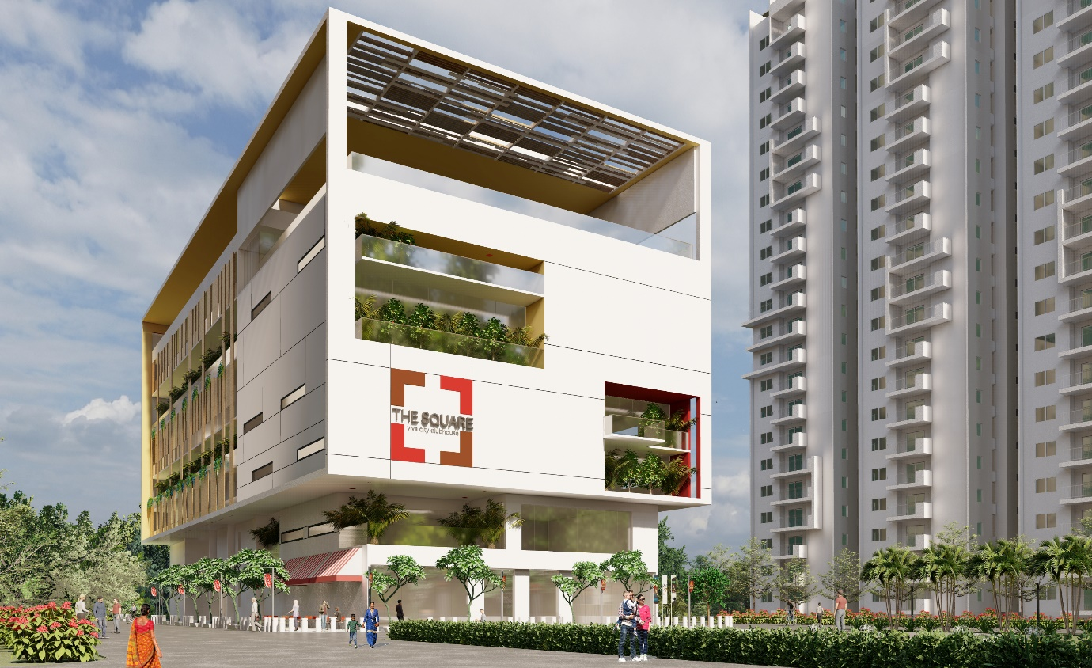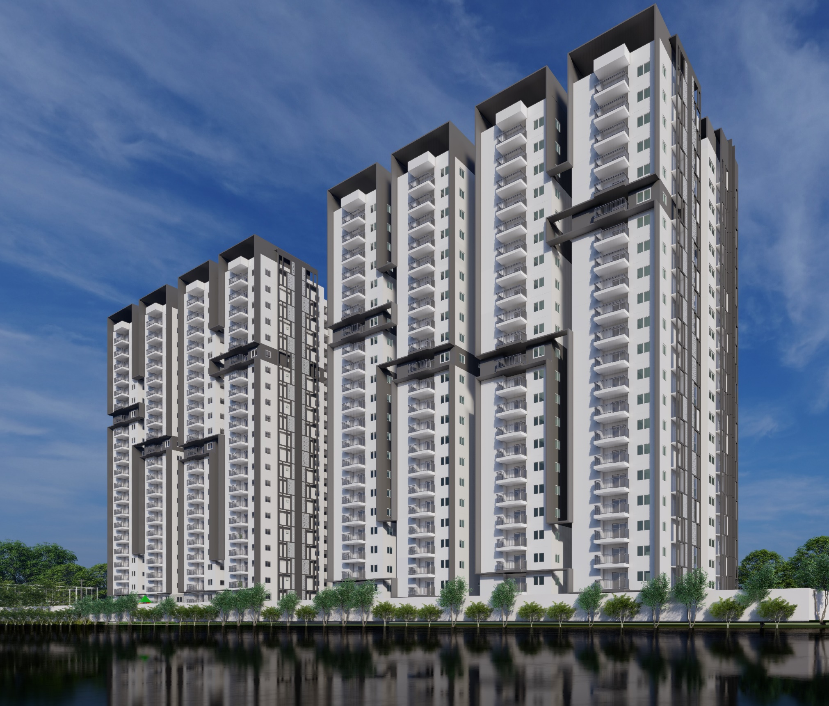

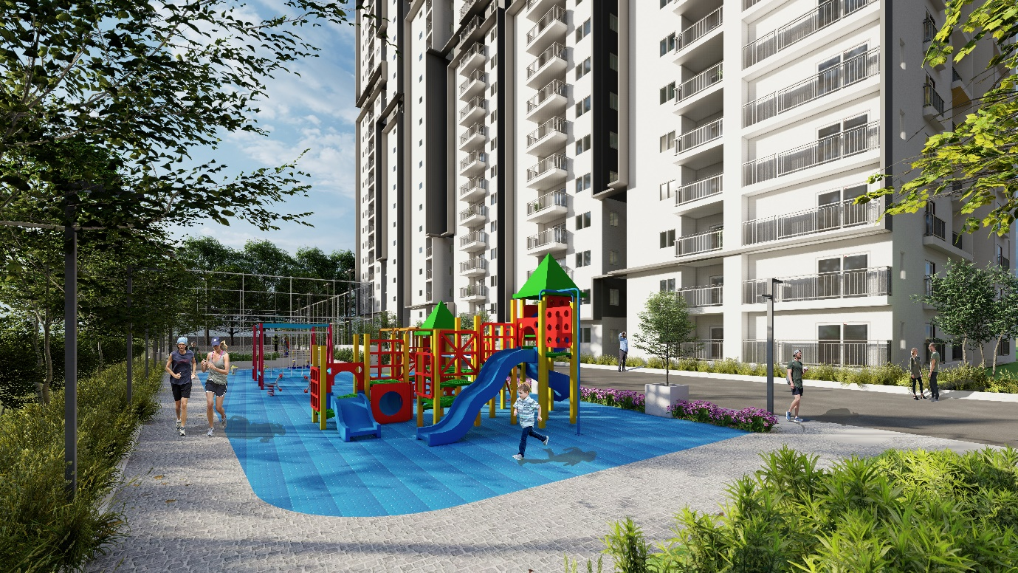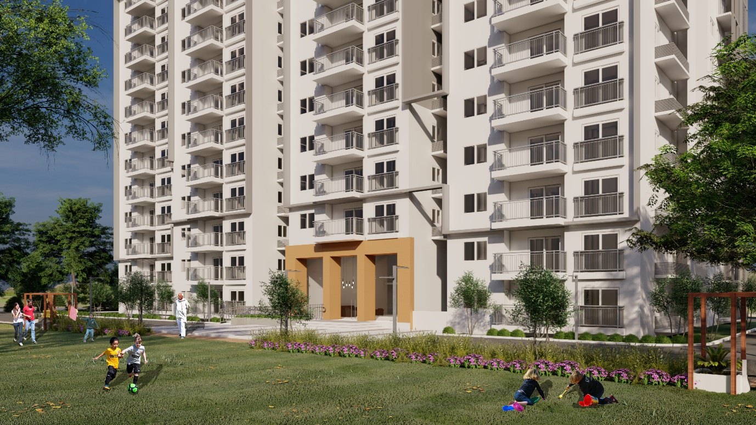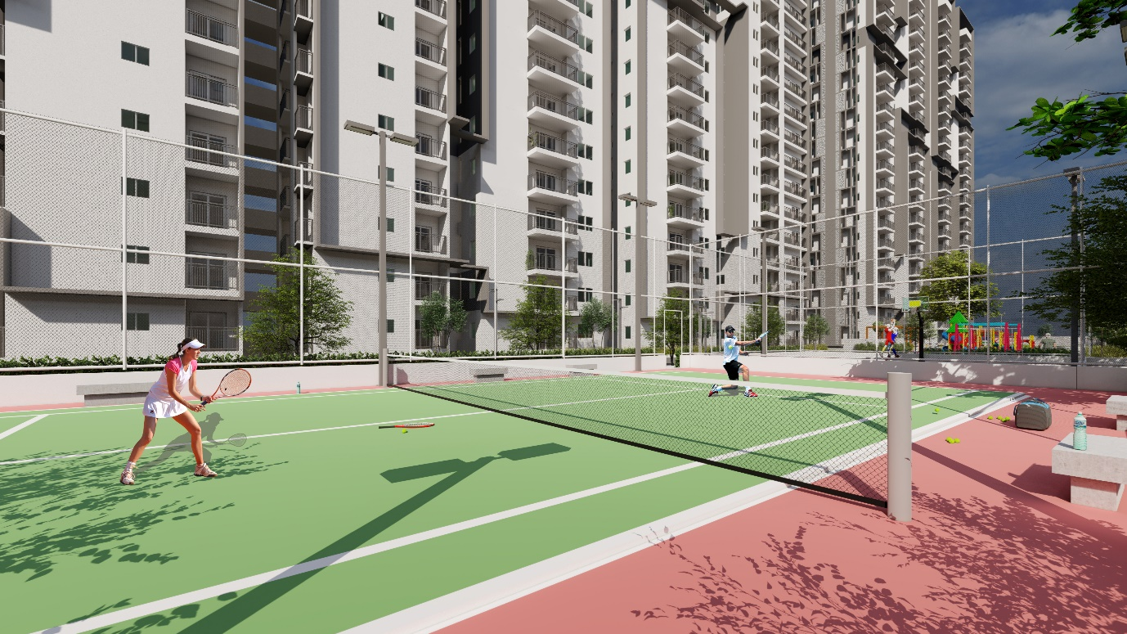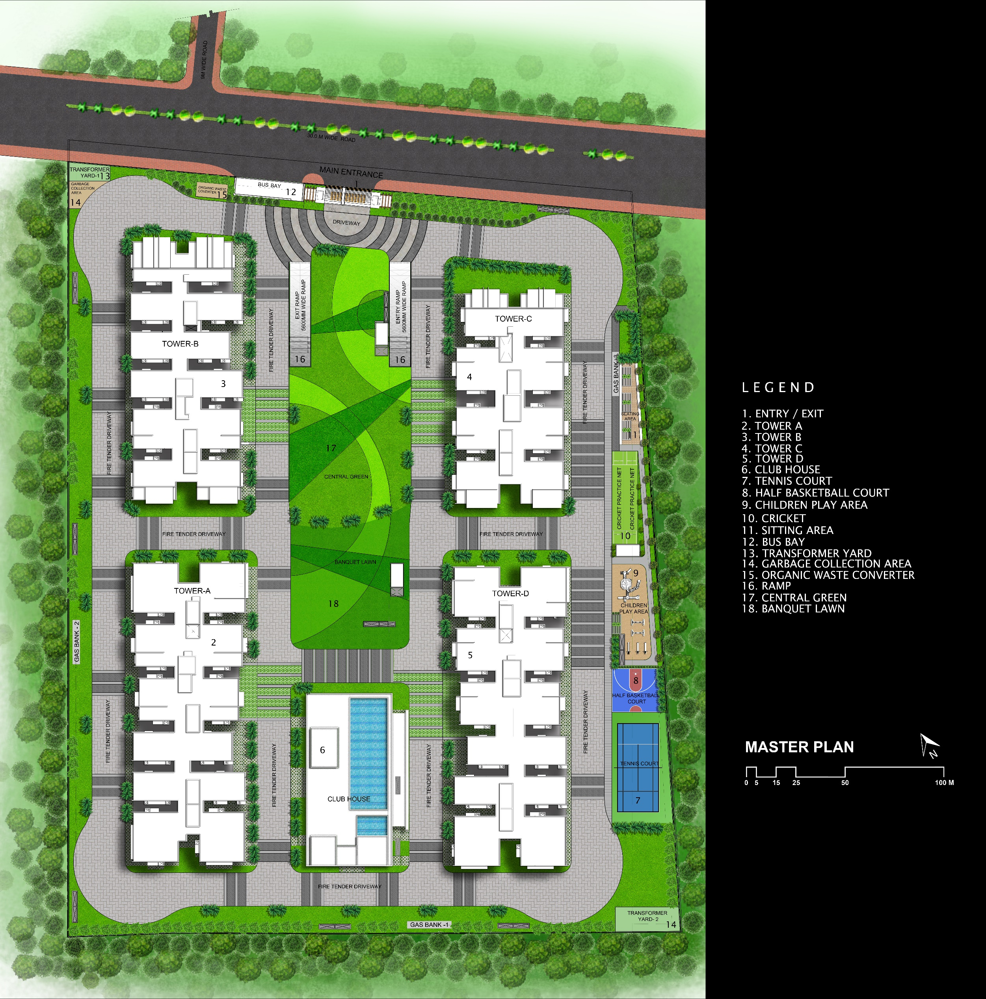

1. Area: 8.15 Acres
2. Scope of services: Concept Master Planning
3. Status: Ongoing
4. Location: Kondapur, Hyderabad
5. Concept: World Class Amenities
6. Description: Indis provided Mofa Architects with the brief to design the masterplan and architectural character for the proposed residential development on the 32,985.25 sq. m. site situated at Kondapur in Hyderabad. The project aims to bring several amenities together in one place. World-class design and safety standards ensure factory-like build quality in each home.

The proposed design comprises high-rise residential towers that integrate open areas and services with the housing units. The clubhouse represents the social, cultural and morphological centre of the site. Overlooking the lush green lawns, the clubhouse houses facilities concerning education, healthcare, recreation, and working.

The four towers are 27 floors each and made of RCC shear wall structure with aluminium formwork. They are a combination of concrete walls and internal blockwork. Three blocks have 12-units on each floor and, the fourth tower has 8-units on a single level. It is to achieve maximum occupancy within existing design controls that govern the site while permitting a rational and functional plan in compliance with the Local Authority Guidelines. Each unit is to be spacious without common walls to ensure privacy.

The project enables panoramic views of the city and landscaped areas within the development. The landscape comprises multigenerational spaces in the east to cater to all age groups.

## PROJECT 12: Indis - Tropica

1. Tagline: A Holistic Approach to Master Planning/Optimizing Functionality/ Goal-Oriented Design
2. Picture:



1. Area:
2. Scope of services: Concept Master Planning
3. Status: Ongoing
4. Location: Mokila, Hyderabad
5. Concept:
6. Description: The project is a blend of commercial and residential properties. A proposal with systemic planning and execution, the masterplan for Indis Tropica accommodates housing and a 4-acre commercial lot. Located at Mokila, on the outskirts of Hyderabad, the project has 226 plots of varying square footage allotted for housing. These plots are well connected to the main road by a network of roads.

A primary 18m wide tree-lined boulevard runs north-south, bifurcating the site into two. Three 12m wide secondary roads cut it perpendicularly, forming round-about junctions. At right angles to the secondary roads and parallel to the 18m road are the 9m wide tertiary roads that adjoin the individual plots. The irregular shape of the site provides for wedge-like corners allotted to accommodate service infrastructure. It includes the likes of transformers, DGs, service towers, etc.

A landmark of the development, the clubhouse is a space envisioned to reinvigorate the community. With a swimming pool, indoor courts, indoor game rooms and multi-purpose halls, it is where everyone comes together. The large open field, next to the clubhouse, doubles as a park and a banquet garden. Multiple open spaces and small gardens dot the site in compliance with the local bye-laws.

## PROJECT 13: KRC Raheja Durgam Cheruvu Lakefront

1. Tagline: Environmentally Positive/ Beautiful Impossibilities/ Moulding the Public Sphere/ Ecological Integrations
2. 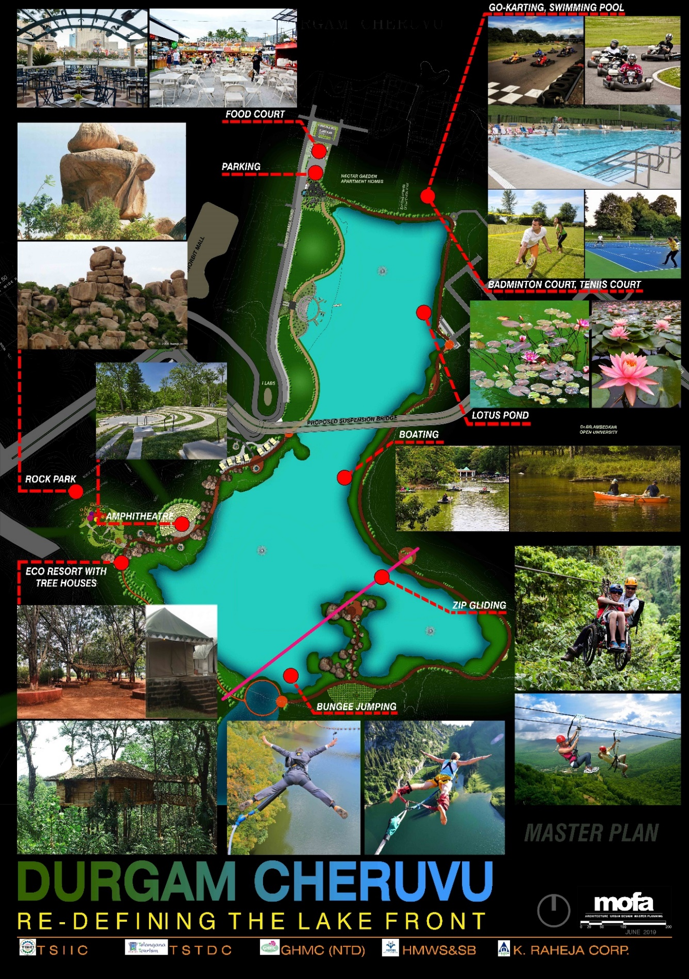Picture:

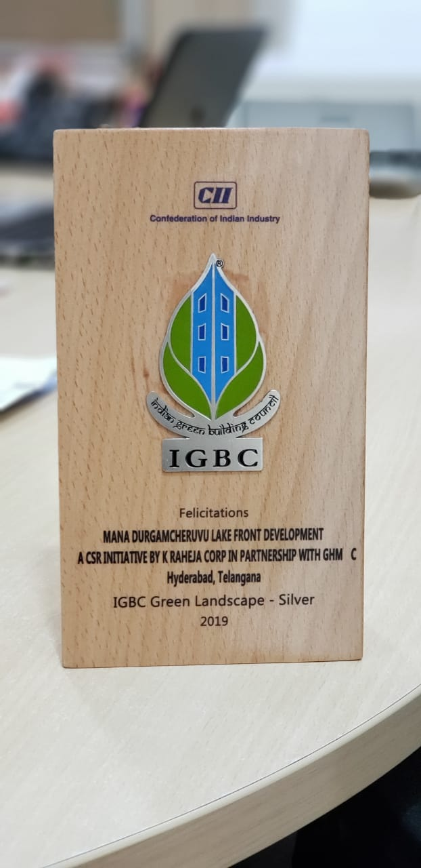

1. Area
2. Scope of services: Concept Master Planning
3. Status: Project Complete
4. Location: Hyderabad
5. Concept: Redefining the Lakefront
6. Description: Recipient of the IGBC Green Landscape Silver award, the Durgam Cheruvu Lakefront is the recreation of 'Heaven on Earth'. A pioneering project in Hyderabad, the development brims with thriving greenery. Handpicked species of native plants revived a deteriorating ecosystem. An eco-sensitive and pragmatic masterplan, the waterfront is strongly influenced by socio-cultural, economic and political determinants.

The rocky and uneven site terrain posed a troublesome challenge. The first design element to be completed was the all-around pedestrian pathway made of compacted earth. It not only improved the accessibility but also prevented the loss of rainwater. It provides for the percolation of water, aiding in groundwater recharge. The promenade along the periphery punctured by yoga corners and shaded seating. It bifurcates into a walking track and a cycling trail. Aside from this, the project boasts rock gardens, immersion ponds, cafes and play spaces, among many others.

Another complication was that of the existing Temple and Mosque. The masterplan integrates these structures of historical and religious value such that it welcomes the public. The religious buildings are reachable through an elevated walkway that joins the eastern and western promenades. The extra-dosed cable-stayed bridge built by L&T constructions, the first of its type in the state, complements the lakefront development.

## PROJECT 14: KRC Raheja Mindspace Campus

1. Tagline: Key to Healthy Lifestyle/ Multi-faceted Architecture/ Conceptualising Impossibilities
2. Picture:

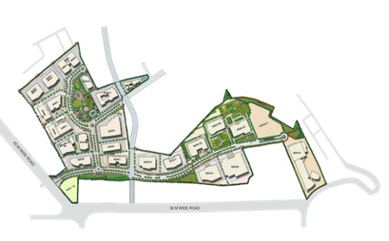

1. Area
2. Scope of services: Concept Master Planning
3. Status: Design Ideation Complete
4. Location
5. Concept
6. Description: A blend of flawless master planning and rejuvenating landscapes, the Mindpsace masterplan redefines the office experience. The balanced approach to this project seeks to change conventional office spaces into collaborative community areas. The site for the Mindspace campus is connected with but not adjacent to the main road.

In the proposal, the side closest to the streets is lined with trees and vegetation to mitigate noise pollution. While there is secondary access from the south-west, the plan is primarily accessible through the southern entry. The streets organically wind through the site correlating vehicular and pedestrian movement. The plot is dotted with meadows and parks to promote physical as well as psychological health. Asymmetrical in the plan, the site has triangular lots radiating in different directions.

The eastern side of the site showcases more greenery proportional to the size of the built environment. The buildings are aligned to maximise airflow and daylight while avoiding glare. The western side of the site showcases a denser built environment oriented around a central plaza. The park comprises walking trails, seating areas, hang-out spaces and reflexology paths.

The masterplan has non-rectangular buildings placed in comfortable proximity to each other. The plan is compliant with the requirements for fire driveways, OSR and additional bye-laws.

## PROJECT 15: KRC Raheja Vistas

1. Tagline: Where Amenities Take Center Stage/ Catering to Multi-gen/ Fostering Eternal Relationships/ A Convenient Neighbourhood
2. Picture:

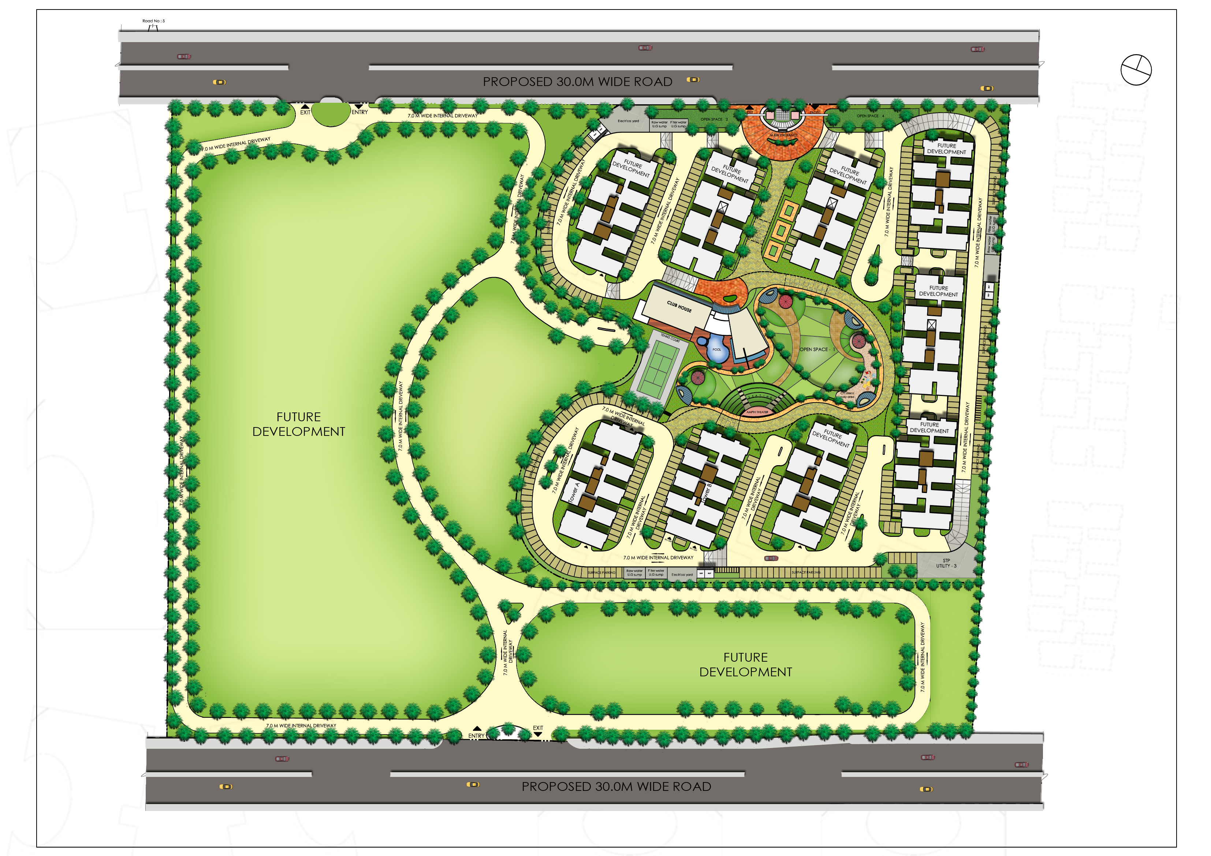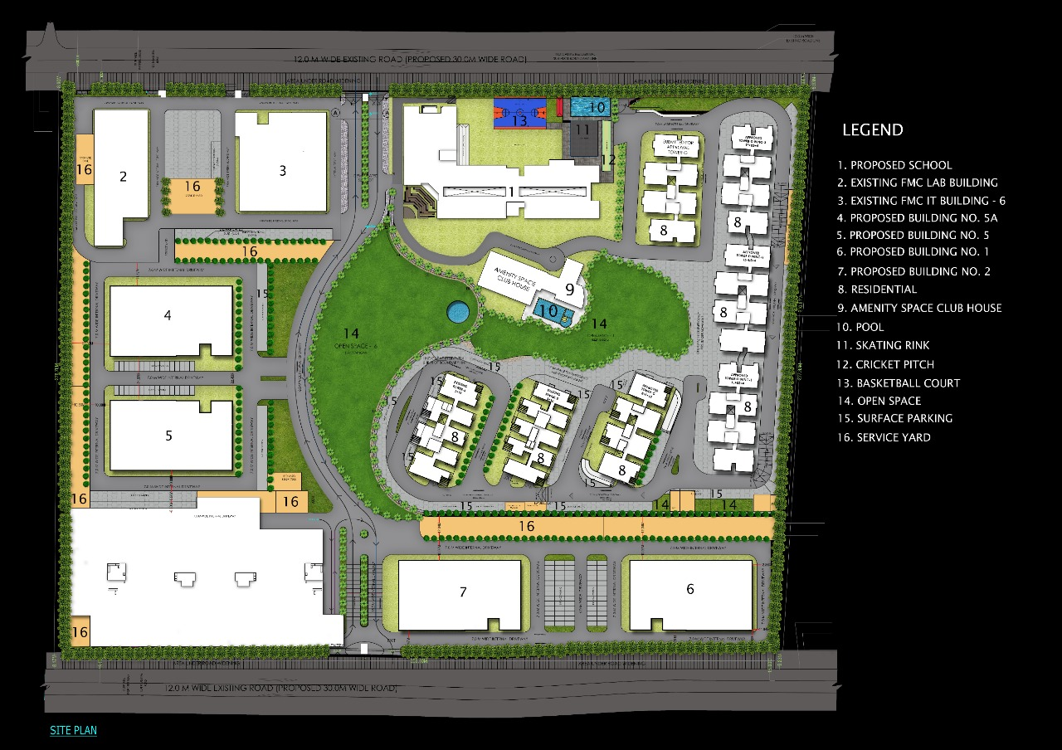

1. Area
2. Scope of services: Concept Master Planning
3. Status: Design Ideation Complete
4. Location
5. Concept
6. Description: A phase-wise development, Raheja Vistas is intended to support high-density living with every amenity in its vicinity. The plan comprises seven high to midrise residential towers of two and three-bedroom apartments. These towers encircle a clubhouse, a swimming pool and other activity spaces. A school on the north, close to the entry, has facilities for education and sports like a library, study areas, a skating rink, a cricket patch, a basketball court and a swimming pool.

The amenities seen in Phase-1, like the clubhouse, OAT, swimming pools and the playing arenas, promote neighbourhood interaction and social growth. The orientation of the buildings veils the functional areas from the main road. As a result of this, the residents enjoy picturesque views and lush lawns. The amenities seen in phase 1, like the clubhouse, OAT, swimming pools and the playing courts, promote community interaction and social growth.

In the second phase of development, existing structures like the FMC lab and the FMC IT building were left untouched and integrated into the master plan. Aside from this, the proposal entails five additional blocks catering to multiple functions. Scattered across the masterplan are numerous service yards and surface parking spaces to serve the requirements.

## PROJECT 16: KRC Raheja School

1. Tagline: Where Design Meets Purpose/ Uplifting Education/ Shaping the Future
2. Picture:

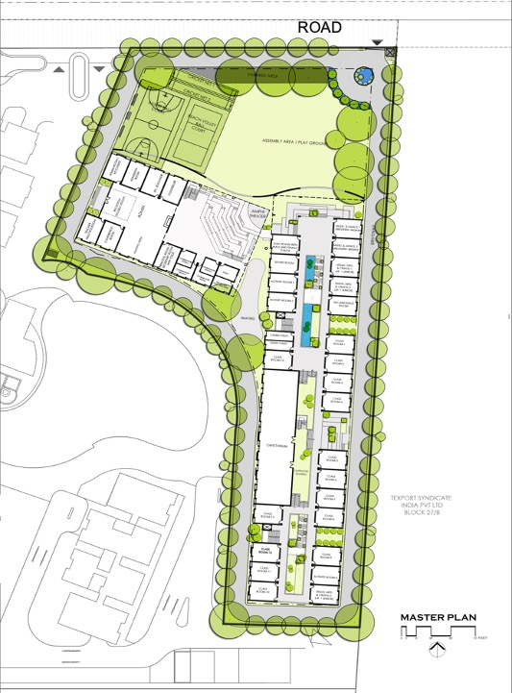

1. Area
2. Scope of services: Concept Master Planning
3. Status: Design Ideation Complete
4. Location
5. Concept
6. Description: A school is a place that nurtures the spirit of young-minds. It is therefore imperative to design educational institutions that boost the academic performance and overall wellbeing of children. KRC Raheja School’s masterplan is the product of extensive research conducted to understand children, their requirements and the management of their surroundings.

The entry to the campus is from the north. A driveway, accessible from the main road, lines the site periphery doubling as the fire tender driveway. The entrance gives way to a playground that becomes the assembly area in the mornings. The sports arena, the open-air theatre and the classrooms succeed the open field. The field manifests two cricket nets, a basketball court and a volleyball court to promote sports amongst the children. The most active region of the campus, the playground, comes to life thrice in a day. Once in the morning for assembly, second during recess and, third after school for sports practise.

After the OAT, one comes across the Administrative block that houses various executive, official and management functions. Adjacent to it is the Educational block that comprises classrooms and staff rooms. The proposal transforms the stretches between the two buildings into hangout spots, lawns and fish ponds for the students. With a well-thought plan, the KRC school masterplan looks into the finer details of how architecture can shape education.

## PROJECT 17: KRC Raheja Image tower

1. Tagline: The Frame of Life/ A Symphony of Design/ Orchestrating Functional Spaces
2. Picture: 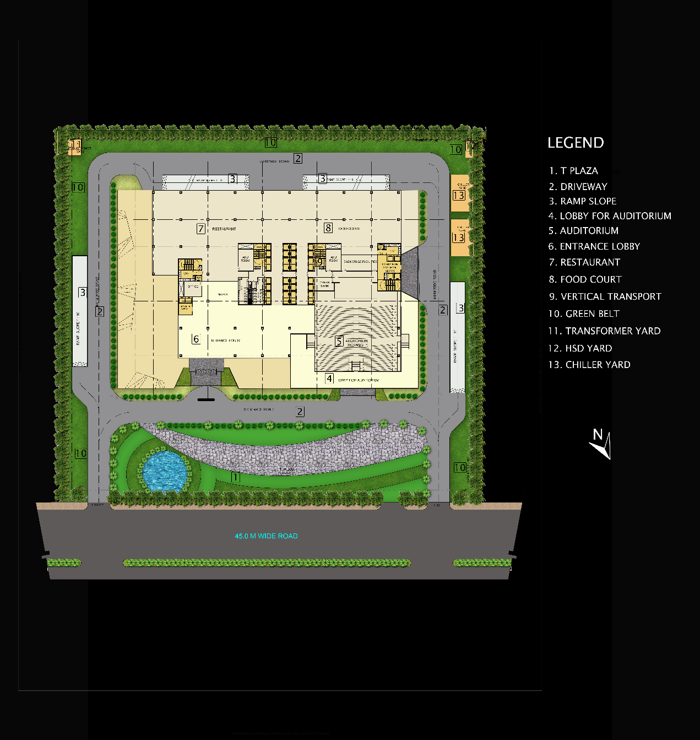
3. Area
4. Scope of services: Concept Master Planning
5. Status: Design Ideation Complete; Concept Master Planning
6. Location
7. Concept
8. Description: The KRC Raheja Image Tower is a project designed holistically for passion, performance and joy. The masterplan integrates outdoor spaces with indoors. The design invites a healthy and zen environment by linking the outside and inside both physically and visually.

Accessible from North, a 9m wide approach guides visitors to the arrival foyer and the auditorium's vestibule. The Koi pond and the landscaped yard accentuate the experience of arrival. The driveway splits into two at the turn and further continues all around the periphery. Four ramps direct vehicles underground to the stilt parking for cars. The driveway is bounded on both sides by planters of native species.

The foyer opens into an entrance hall adjoining a reception. The office to the west of the reception houses administrative functions. Two corridors, with multiple lifts, connect the lobby to the restaurant and the food court. It is here that the building envelope flows into the building, bringing the backyard indoors. The second vestibule, accessed from the driveway, leads into the auditorium with a seating capacity of 850 people. Equipped with additional spaces like the green room, backstage facilities, staircases and galleries, the theatre comes to life. A side entrance leads to the stairs and lifts for the Academic Block. All in all, the project speaks through its volumes.

## PROJECT 18: KRC Raheja IT Raidurg- Hetero Masterplan

1. Tagline: Pioneering Work Spaces/ Offering Sustainable Solutions/ Transforming Ideas
2. 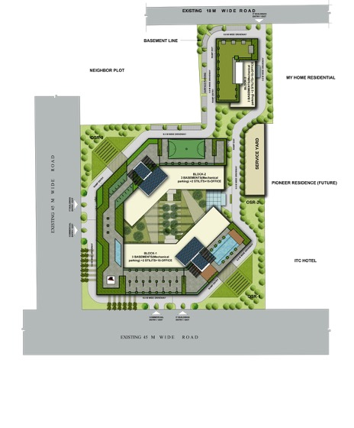Picture:
3. Area
4. Scope of services: Concept Master Planning
5. Status: Design Ideation Complete
6. Location
7. Concept
8. Description: They say that to work is to worship. At Mofa, the principal goal is to craft human experiences through the language of design. The IT Raidurg Hetero-masterplan is an attempt to achieve the same by redefining traditional Office spaces.

Bounded by roads on three sides, the masterplan is accessible and provides convenient mobility to its campus users. The campus exhibits parking for cycles aside from the four and two-wheeler parking. Three office blocks take centre stage in the built environment. Block 1 and 2 enclose a trimmed garden that tapers out on either end to landscaped areas. The third block is further north, slightly away from the two towers.

The campus has playing courts and swimming pools to rejuvenate the office-goers after a long day at work. Green roofs and terrace lawns create recreation spaces on the top of the buildings. As per the proposal, the terraces will house cafes and eateries that deliver a world-class dining experience for the employees at KRC. With terraced gardens that use recycled greywater, green pockets and solar panels, the plan is sustainable and energy-efficient. In compliance with local bye-laws and fire-laws, the masterplan showcases optimal OSR spaces and service yards with backup facilities.

## PROJECT 19: KRC Raheja Pocharam Masterplan

1. Tagline: A Holistic Approach to Living/
2. / Picture:

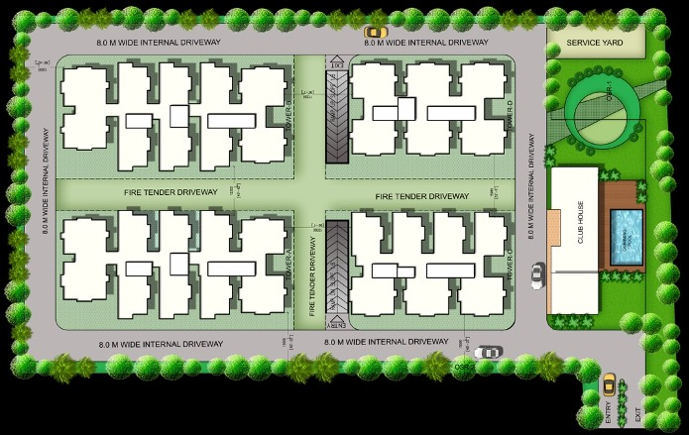

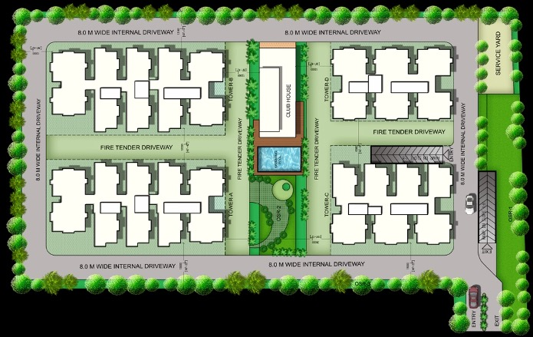

1. Area
2. Scope of services: Concept Master Planning
3. Status: Design Ideation Complete
4. Location
5. Concept
6. Description:

## PROJECT 20: KRC Raheja Tropica

1. Tagline: Promoting a Sustainable Tomorrow/ Tranquility Like No Other/ Energy Efficiency at its Best/ Sound-proofing Your World
2. 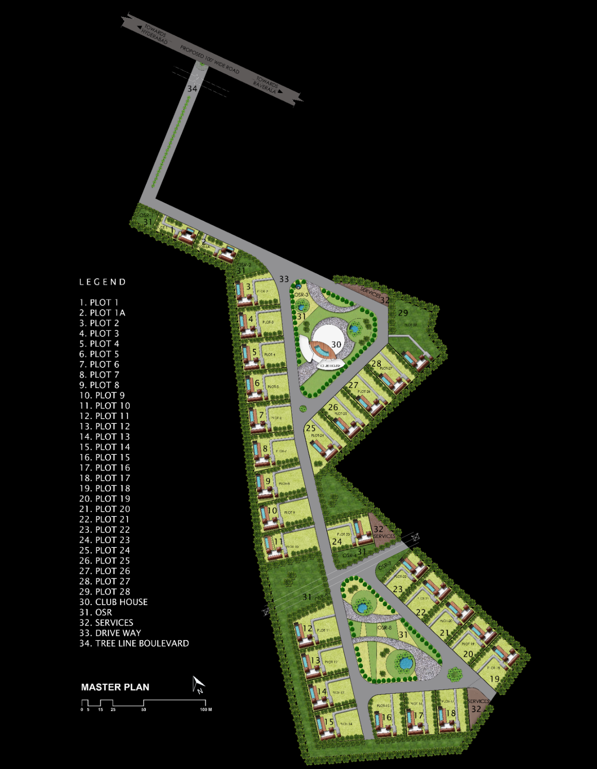Picture
3. Area: approx. 350 Acres for Phase 1
4. Scope of services: Concept Master Planning
5. Status: Design Ideation Complete
6. Location: Ranga Reddy District, Hyderabad
7. Concept
8. Description: Nestled away from the city’s hustle and bustle, KRC Raheja Tropica is a gated residential development of roughly 30 plots. Situated near the aircraft corridor of Hyderabad, the project is a testament to the importance of acoustics in residential design.

Uniquely shaped, the site resembles the letter B in the plan. Thus, the design proposes two triangles of residential plots such that each triangle has a central amenity. In the north, the triangle sports 17 units encircling a centrally located clubhouse and gardens. The southern triangle, comprising of 12 plots, encompasses landscaped gardens and two water ponds. A challenge in this triangle was the high tension line that runs across the campus. In compliance with the bye-laws, an estimation for the safe-distance was undertaken before the planning began.

The design employs acoustic treatment on both site and individual plot level. A thicket of plantation lines the edge of the development and serves as a noise barrier. Rows of trees along the boundary of each plot, in addition to the acoustically treated homes, create a tranquil environment. The development is accessible through an internal road connecting the main road and the dwelling units. This road provides a sense of leaving the world behind as one comes home.

## PROJECT 21: Praneeth Navjeevan Master Plan

1. Tagline: Climate-conscious Master Planning/ Exploring Unlimited Potential/ In The Lap of Luxury
2. Picture:

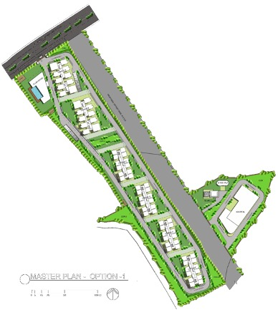

1. Area
2. Scope of services: Concept Master Planning
3. Status
4. Location: Velimela, Hyderabad
5. Concept
6. Description: The proposal for Praneeth Navjeevan comprises remarkably well-planned apartment homes. Designed to bring you a luxurious and abundant lifestyle caressed by nature, this project in Velimela offers facilities seldom found in this part of Hyderabad. The masterplan is a combination of spacious floor plans, elegant interiors and indoor and outdoor amenities. Encompassed by stunning views, the project connectivity to other parts of the city is high.

Six towers oriented North-south line the site. Optimally spaced, the buildings comply with local bye-laws and service requirements. The apartment configurations comprise 1BHK, 2BHK, 2.5BHK and 3BHK of varying square footage. Elaborate and carefully designed architectural plans for each apartment make it stand apart from the rest. A clubhouse to the west of the entrance houses games, exercise and fitness activities. It has a wide array of amenities for both entertainment and education.

Thoughtfully planned, the play areas have different types of equipment for use by children. A 9m wide road runs along the periphery of the site connecting all buildings. The stilt parking is accessible from the side of the first tower and, the vehicles exit from the ramp located on the other side of the second tower. Lush green yards surround each block that makes your evenings and mornings a delight.

## PROJECT 22: Praneeth Urvi Masterplan

1. Tagline: Best of Both Worlds/ Chronicles of Design/ Best of Both Worlds/ Blooming in Nature
2. 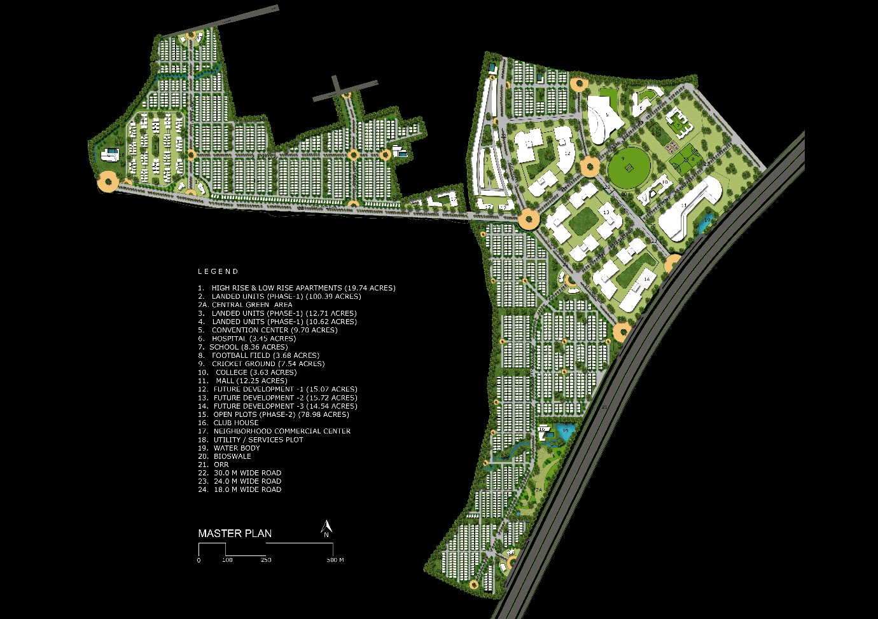Picture:
3. Area: approx. 350 Acres for Phase 1 out of which 100 Acres are for retail
4. Scope of services: Concept Master Planning
5. Status: Design Ideation Complete
6. Location: Baurampet (ORR exit-4), Hyderabad
7. Concept
8. Description: Encompassing concepts of sustainable design and compliance to Vastu principles, the Urvi masterplan is a world of youthful living. The site is a combination of thoughtful planning, regulated imageability, urban design and efficient landscaping.

A pragmatic yet sensitive methodology to design increased the usability of the project. Tree-lined boulevards shade every pathway throughout the campus. Vehicles reach their destination after journeying through the grid of roads systematically laid by HMDA (Hyderabad Metropolitan Development Authority). The plan conforms to relevant bye-laws and regulations.

Trees and roads line the periphery of the site. Green pockets dot the development and are within a distance of 100-250m from each dwelling unit. These pockets envelop play areas and multigenerational landscapes catering to people of all ages, from children to the elderly.

The project, categorized into three broad sectors based on cardinal directions, comprises countless amenities knit into the residential fabric. The western end of the site sports open plots, high-rise and low-rise apartments. A meticulously planned stretch of bio-swales flows through the north-western edge of this sector. The north-eastern side of the site, the heart of the project, boasts a broad spectrum of activities ranging from healthcare and educational institutions to a convention centre and a mall. The southern sector of the site comprises compact smart villas along with high-rise and low-rise apartments. This end also sports a golf course and clubhouses planned nearby a water body. The amenities within this development, accessible to both residents and non-residents, make this project a self-contained unit on the outskirts.

## PROJECT 23: Vajra's Pride Masterplan

1. Tagline: The Epicentre of Life/ Welcome to Your New Home / Adding Meaning to Everyday
2. Picture:

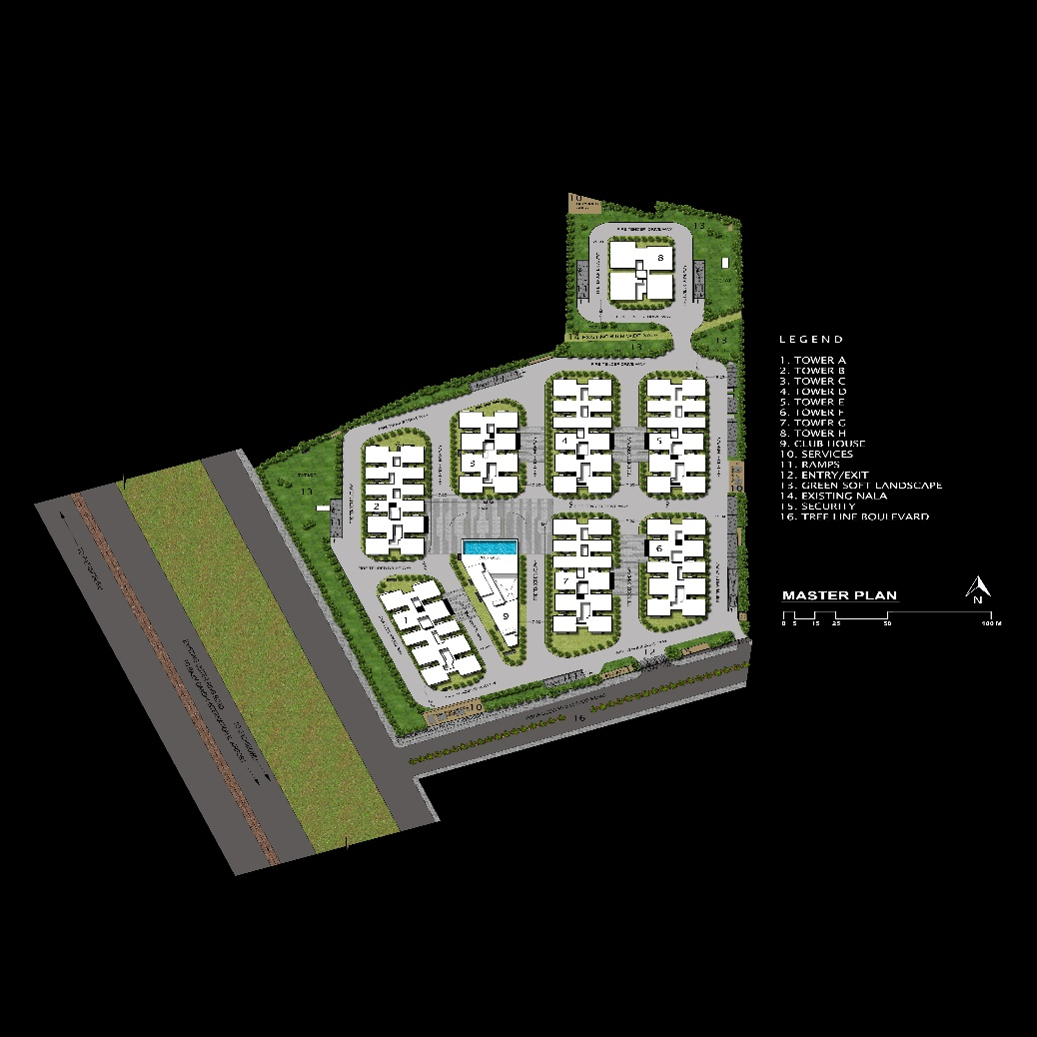

1. Area: 13 Acres
2. Scope of services: Concept Master Planning
3. Status
4. Location: Hyderabad
5. Concept
6. Description: A collaboration between Mofa Architects and the Vajra InfraCorp India Pvt. Ltd., the Vajra Pride masterplan is along the outer ring road. It is a project that offers not just a home but an assurance of a wholesome lifestyle. Well-connected to other parts of Hyderabad, the main road adjoining the site connects to Gachibowli, Rajiv Gandhi International Airport and Patanchuru. The site is in proximity to shopping malls, theatres, schools and hospitals, making everything within reach.

Seven residential towers ranging from high-rise to mid-rise stretch across the campus. Tower 1 and Tower 6 have ten apartments on each floor whereas, Towers 2, 4, 5 and 7 have twelve flats on each floor. Different from the rest, Tower 3 has eight flats per floor. Premium homes for an opulent lifestyle are in Tower 8 which, proposes four apartments per floor. A clubhouse equipped with state-of-art facilities is between Towers 1, 2, 3, 4 and 7. The project proposal upkeeps with the signature style of the Vajra group. It has a host of conveniences like the Gymnasium, a Party hall, an indoor games area, a swimming pool and a plaza. By-law compliant fire-safety compliant, the project is an environmentally friendly home for the urban resident.

# CONCEPTUAL PROJECTS

## PROJECT 1: The Urban Spine as a Social & Spatial Connector (The Case of Ramappa Lake & Temple)

1. Tagline: Pinnacle of Design/ Shaping Spirituality/ Elements of Planning
2. 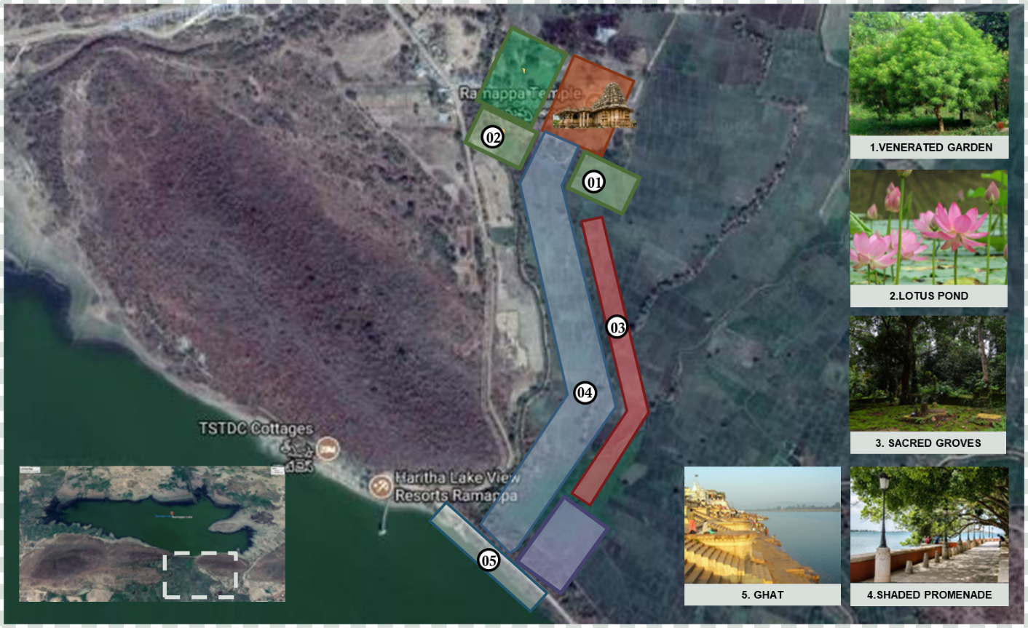Picture
3. Area: 82 Acres
4. Scope of services: Concept Planning
5. Status: Conceptual Design Complete
6. Location: Warangal
7. Concept
8. Description: The Ramappa Lake and Temple were built by a Kakatiyan ruler in the 13th Century. The purpose of building a lake 1km from the temple was to provide irrigation to the local farmers and serve as a recreational spot for the village folk.

The conceptual masterplan, as designed by Mofa Architects, binds the temple and the lake together through a shaded promenade. A venerated garden, a lotus pond and sacred groves have also been proposed.

The garden is to grow plants used for worship and the groves are communally protected fragments of forests which have significant religious importance to the local folk. The plan also suggested the use of a stepped ghat to provide easy access to the lake for ritualistic purposes.